Suggested text for 2016 Institution wide e-mail blast
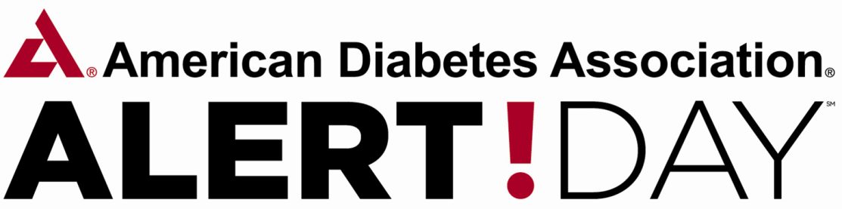
March 22nd is American Diabetes Associations' Alert Day, a "wake-up" call for Americans to understand their risk for developing diabetes. An estimated 86 million adults in the United States have pre-diabetes, or are at risk, for developing diabetes. Only 1 in 10 of these adults is aware of their risk! To see if you are at risk for diabetes and whether you qualify for the D2d Study, a national diabetes prevention study being conducted at insert institution name, please email insert local e-mail address, call ###-###-#### or complete a questionnaire at d2dstudy.org/risk.
Please stop by the Diabetes Alert Day table in the insert location on March 22nd from hh:mm AM to hh:mm PM to take the diabetes risk test and speak with clinical experts in diabetes/pre-diabetes.

