Sample Alert Day 2016 text for a printed Newsletter

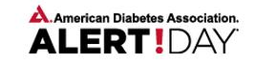
March 22, 2016
The American Diabetes Association and the D2d study want everyone to know if they are at risk for diabetes. Please encourage your friends and family to know their diabetes risk by taking the Diabetes Risk Test at http://www.d2dstudy.org/prediabetes/ where they can also find out if they qualify for D2d. Enrollment into the D2d study will close in the summer of 2016.

