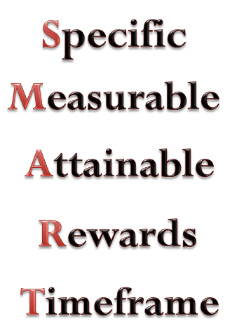
Goal Setting

Goal #1: I want to: _______________________________________________________________________

Describe the behavior as specifically as possible: ___________________________________________

How will you measure success?: ________________________________________________________

Is this attainable?: ______________

When will you complete the goal? (What’s the deadline?): ___________________________________

How will you reward yourself when you meet your goal?: ____________________________________

Goal #2: I want to: _______________________________________________________________________

Describe the behavior as specifically as possible: ___________________________________________

How will you measure success?: ________________________________________________________

Is this attainable?: ______________

When will you complete the goal? (What’s the deadline?): ___________________________________

How will you reward yourself when you meet your goal?: ____________________________________

