A small, inexpensive pedometer will be given to all attendees of the Spring 2015 Participant Event (“Increasing Activities of Daily Living”). These will be provided to all sites by the Coordinating Center. They will also be used as the retention give-away item to all participants at their Month 24 visit.
Pedometer details
- This pedometer tracks steps taken on an LCD screen
- Belt clip holds the pedometer to the waistband for the most accurate tracking
- Includes one button-cell battery for portable operation.
- Size: 1-3/8" x 1-7/8" x 3/4"
Front view
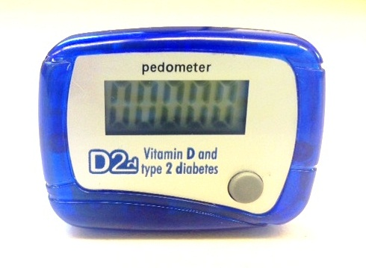
Back view
