D2d Pre-Screening Inclusion-Exclusion Criteria Sample Questionnaire (Note: This prescreening questionnaire does not replace the thorough medical history and review of inclusion/exclusion criteria done at screening to determine study eligibility)
1. How old are you? | If < 30 years.
2. Do you have diabetes or have you ever been told you have diabetes? | If yes, participants who have or have had diabetes* are not eligible  *with the exception of gestational diabetes. If a woman reports she had diabetes, ask her when and if it was during a pregnancy, and then resolved this is not an exclusion

3. What race do you consider yourself?
4. What is your height?  What is your weight? | Calculate BMI using the calculator at http://nhlbisupport.com/bmi/bminojs.htm (also available as a smartphone app) or if computer unavailable use the table below.  - If BMI > 40  - If BMI < 23 and caller considers herself as Asian  - If BMI < 25 and caller is not Asian
5. What medications do you currently take and for what problems? | - If caller takes an exclusionary medication  Compare the medications the caller to takes to those on the exclusionary medication list (MOP Section 8.5) and make note of the reasons for taking the medication
In the past 6 months, have you had to take steroid medications by mouth (examples: prednisone, decadron, Medrol) for 7 days or more? | - If yes,  Note: inhaled glucocorticoids are not excluded
In the past 6 months, have you had to take intravenous steroid medications (decadron, hydrocortisone, solumedrol)? | - If yes,  Note: inhaled glucocorticoids are not excluded
6. Do you take any dietary supplements (vitamins)?  If yes,  Do you take vitamin D? How many units?  Do you take any calcium or supplements with calcium? How many milligrams a day? | If caller takes >1000 IU of vitamin D per day and is unwilling to reduce the amount he takes.  - If caller takes > 600 mg of calcium per day and is unwilling to reduce the amount he takes.
7. Do you visit tanning salons (tanning booths or beds)? If yes, when was the last time? | If caller visits tanning salons and will not stop for the duration of the study.
8. Do you have an allergy to soy? | If yes
9. Do you have:  chest pain?  difficulty breathing with activities or while sleeping?  heart failure?  leg pain while walking?  an irregular heart beat that causes symptoms? | If yes, to any
10. In the past year have you had:  A heart attack, angioplasty, placement of a heart stent?  A stroke or transient ischemic attack? | If yes, to any
11. Do you have:  - kidney disease?  - liver disease, such as hepatitis?  - tuberculosis?  - AIDS?  - COPD, and need to use oxygen?  - Cushing’s syndrome? | If yes, to any
12. Have you had cancer in the past 5 years?  If yes, what type? | If yes*  *You may continue if it was basal cell skin cancer, or prostate cancer in a man >55 years old, or thyroid cancer (note additional information will be needed regarding the diagnosis).
13. Have you ever had bariatric (or weight loss) surgery? | If yes*  *You may continue if participant had gastric banding more than 2 years ago and has had a stable weight of for the past 6 months (=/-6.6 lbs or 3kg)
14. In the past 3 years have been told you have (or had):  kidney stone(s)?  - hyperparathyroidism (overactive parathyroid gland(s)?  - hypercalcemia (too much calcium in your blood)? | If yes, to any
15. Do you have any major surgery planned? | If yes
16. Have you had a life threatening event in the past 30 days? | If yes

If female:
17. Are you pregnant, or have you been pregnant in the last year?  If no, do you intend to become pregnant in the next 4 years? | If yes
18. Are you breastfeeding? | If yes
19. Have you started using oral contraceptives or estrogen therapy in the last 3 months? | If yes, participant needs to be on the medication for at least 3 months at the time of the baseline visit. Consider postponing visit if other criteria are met.

If caller appears to meet the eligibility criteria you may continue with the Diabetes Risk Test

Body Mass Index Table
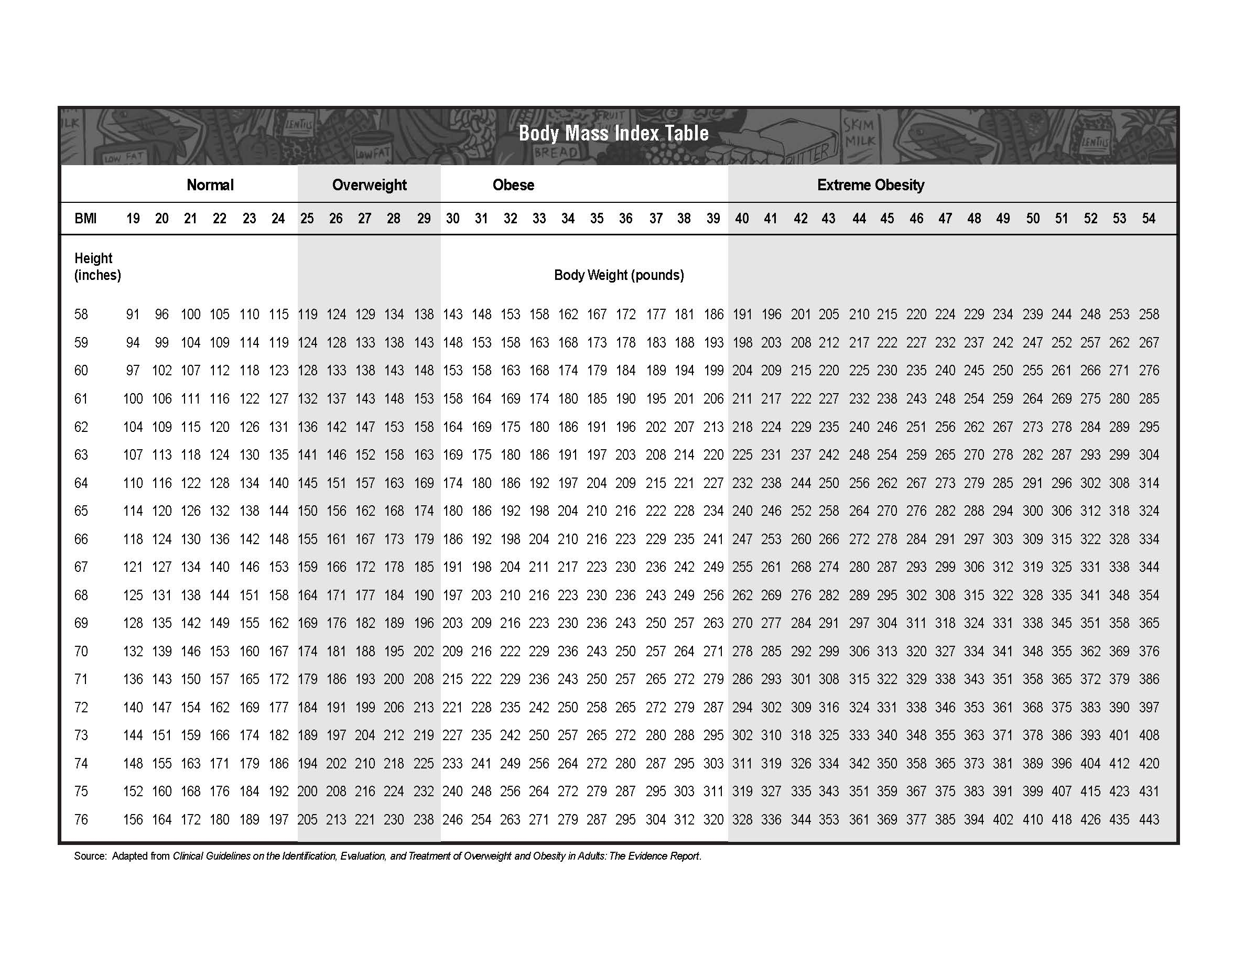
Double check using BMI calculator if BMI falls on border
Double check I using BMI calculator if BMI falls on border
Meets BMI criteria only if Asian

Meets BMI criteria, all races

