
Manual of Procedures
Section 18. Primary Outcome Assessment
Table of Contents
18.1 OVERVIEW OF PRIMARY OUTCOME 2
18.2 LABORATORY DIAGNOSIS OF DIABETES 3
18.3 DIABETES DIAGNOSED WITHIN THE D2D STUDY 3
18.3.1 Glycemia testing at scheduled visits 3
18.3.1.1 Glycemia testing at annual visits 3
18.3.1.2 Glycemia testing at semi-annual visits 5
18.3.2 Glycemia testing for symptoms consistent with hyperglycemia 6
18.3.3 Glycemia testing at end-of-study visit 6
18.3.3 Glycemia testing for diabetes outside of the D2d study or use of diabetes medication 6
18.4 POSTPONEMENT OF GLYCEMIA TESTING 8
18.5 DIABETES DEVELOPMENT OUTSIDE OF D2d 8
18.5.1 Non-D2d Diabetes Diagnosis Worksheet 9
18.5.2 Diabetes-specific pharmacotherapy started in between study visits 11
18.5.3 Retrieval of medical records 11
18.5.4 Adjudication of Diagnosis of Diabetes 12
18.6 DATE OF DIABETES ONSET 13
18.7 MANAGEMENT OF PARTICIPANTS AFTER DIAGNOSIS OF DIABETES 14
18.8 SUBMITTING RECORDS TO THE COORDINATING CENTER 14
18.9 APPENDICES 16
Appendix 1. Diabetes Specific Medications 16
Appendix 2. Non-D2d Diabetes Adjudication Worksheet 16
Appendix 3. Non-D2d Diabetes Adjudication Review Form 16
Appendix 4. Adjudication Source Document Coversheet 16

18.1 OVERVIEW OF PRIMARY OUTCOME

The primary outcome of the D2d study is time to progression from pre-diabetes to incident (new-onset) diabetes.

The diagnosis of diabetes is made based on one of the following mechanisms (Figure 18.1):

- Within study diagnosis, based on glycemic criteria from laboratory testing conducted during D2d study visits and analyzed at the Central Laboratory. This mechanism includes glycemic testing during scheduled study visits or unscheduled visits, e.g. to confirm a diagnosis of diabetes given to a participant outside of the study or to establish the diagnosis before a participant initiates diabetes-specific pharmacotherapy (prescribed for any reason).
- Outside of study [non-D2d] diagnosis, based on clinical and laboratory data that have been collected outside of the D2d study. In this mechanism, which is expected to be rare, there are no available D2d glycemic measures measured at the Central Laboratory and the independent Clinical Outcomes Committee (COC) confirms the diagnosis of diabetes by an adjudication process.

Figure 18.1. Summary of algorithm for evaluation of diabetes

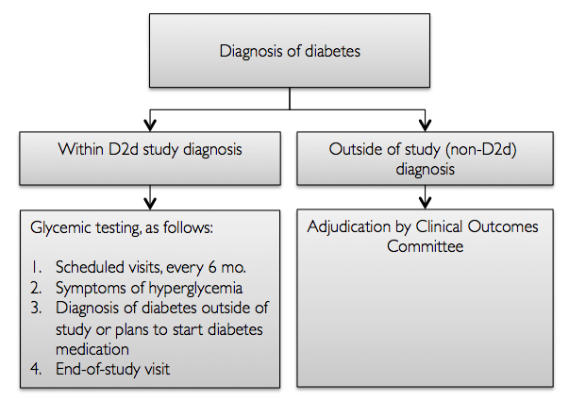

18.2 LABORATORY DIAGNOSIS OF DIABETES

The diagnosis of diabetes is based on the American Diabetes Association (ADA) glycemic criteria (fasting plasma glucose [FPG] ≥ 126 mg/dL, 2-hour post 75-gram glucose load [2hPG] ≥ 200 mg/dL or hemoglobin A1c [HbA1c] ≥ 6.5%) measured at study visits, according to the algorithms described below. During D2d study visits, blood for plasma glucose (FPG, 2hPG) and whole blood (HbA1c) is drawn locally and shipped to the Central Laboratory for measurement. Results are available to the site typically within 5 business days from day of shipment.

The same ADA glycemic criteria used during D2d study visits will also be used when the diagnosis of diabetes is confirmed by the adjudication process based on laboratory data collected outside of the D2d study, as described below.

18.3 DIABETES DIAGNOSED WITHIN THE D2D STUDY

Glycemic testing for diabetes during the D2d study will be done: (1) at scheduled visits, every 6 months, (2) when a participant reports symptoms consistent with hyperglycemia, (3) when a participant is given a diagnosis of diabetes outside of the D2d study or plans to start diabetes-specific pharmacotherapy (prescribed for any reason) or (4) end-of-study visit (Figure 18.1).

When a participant meets a laboratory criterion for diabetes at a study visit, the site will be notified via the web-based electronic data (EDC) capture system where the Central Laboratory enters the results of the glycemic measurements. In many cases, repeat testing will be required to confirm the diagnosis of diabetes (see below for algorithm).

18.3.1 Glycemia testing at scheduled visits

18.3.1.1 Glycemia testing at annual visits

All three glycemic measures (FPG, 2hPG and HbA1c) will be assessed (see MOP 9) at scheduled yearly visits (M12, M24, M36 and M48) by conducting a 75-gram OGTT, and the diagnosis of diabetes will be made based on the algorithm shown in Figure 18.2 (same as Protocol - Figure 9.1.1).

- If all three glycemic measures are negative for diabetes, then the participant does not have diabetes and continues on the assigned treatment and continue to be tested for incident diabetes every 6 months.
- If two or all three of the glycemic measures are positive for diabetes, the participant is considered to have reached the diabetes outcome and no confirmatory testing is required.
- If only FPG or only HbA1c is positive for diabetes, then a confirmatory visit to repeat only the same glycemic test that was positive will be completed within 8 weeks. If the repeat measure is also positive for diabetes, then the participant is considered to have reached the diabetes outcome.
  - Example: HbA1c = 6.5%, FPG = 119 mg/dL and 2hPG = 178 mg/dL at the scheduled annual follow-up visit; HbA1c = 6.6% at the confirmatory visit. Participant is diagnosed with diabetes.
- If only the 2hPG is positive for diabetes, then a confirmatory visit with an OGTT to repeat all three glycemic measures is completed within 8 weeks. If the repeat 2hPG is positive for diabetes, then the participant is considered to have reached the diabetes outcome. If the repeat 2hPG is negative for diabetes but both repeat HbA1c and FPG are positive for diabetes, then the participant is considered to have reached the diabetes outcome. Otherwise, the participant does not have diabetes and continues on the assigned treatment and continues to be tested for incident diabetes every 6 months.
  - Example: HbA1c = 6.4%, FPG = 122 mg/dL and 2hPG = 204 mg/dL at the scheduled annual follow-up visit; HbA1c = 6.6%, FPG 128 mg/dL and 2hPG = 189 mg/dL at the confirmatory visit. Participant is diagnosed with diabetes.

Figure 18.2. Flow diagram of laboratory evaluation for diabetes at the annual visit

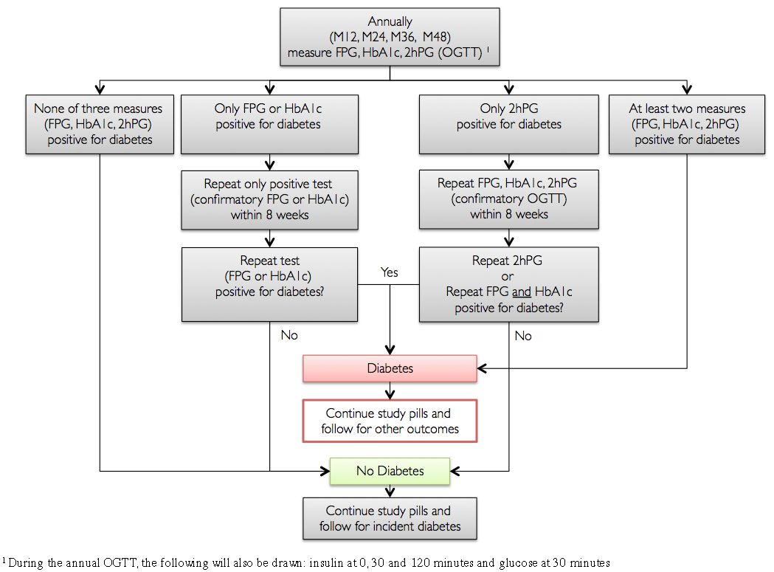

18.3.1.2 Glycemia testing at semi-annual visits

Fasting plasma glucose and HbA1c will be assessed (see MOP 9) at scheduled semi-annual visits (M06, M18, M30, M42) and the diagnosis of diabetes will be made based on the algorithm shown in Figure 18.3 (same as Protocol - Figure 9.1.2).

- If both glycemic measures are negative for diabetes, then the participant does not have diabetes and continues on the assigned treatment and continues to be tested for incident diabetes every 6 months.
- If both glycemic measures are positive for diabetes, the participant is considered to have reached the diabetes outcome and no confirmatory testing is required.
- If only one of two glycemic measures (FPG or HbA1c) is positive for diabetes, then a confirmatory visit to repeat only the same glycemic test that was positive will be completed within 8 weeks. If the repeat measure is also positive for diabetes, then the participant is considered to have reached the diabetes outcome.
  - Example: HbA1c = 6.3% and FPG = 127 mg/dL at the scheduled semi-annual follow-up visit; FPG = 129 mg/dL at the confirmatory visit. Participant is diagnosed with diabetes.

Figure 18.3. Flow diagram of laboratory evaluation for diabetes at the semi-annual and end-of-study visits

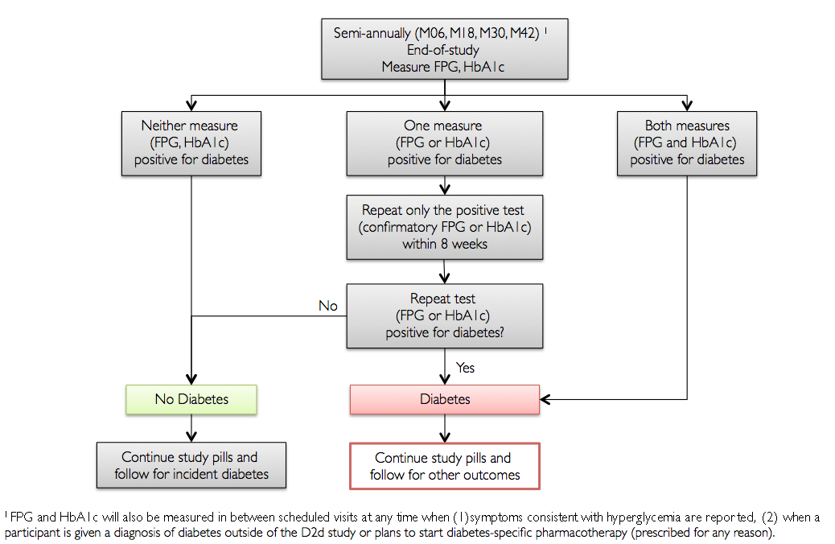

18.3.2 Glycemia testing for symptoms consistent with hyperglycemia

At any time when a participant reports symptoms consistent with hyperglycemia (see below), a visit should be scheduled as soon as possible to measure FPG and HbA1c. The algorithm for the semi-annual visit, described above (Figure 18.2), will be followed.

Symptoms of hyperglycemia include:

- Blurry vision
- Excessive thirst
- Excessive hunger
- Frequent urination
- Extreme fatigue
- Unexplained weight loss
- Frequent infections

18.3.3 Glycemia testing at end-of-study visit

At the end-of-study visit, which will take place within 3 months after study close-out begins, FPG and HbA1c will be measured and the algorithm for the semi-annual visit (Figure 18.3) will be followed to assess for incident diabetes.

18.3.4 Glycemia testing for diabetes outside of the D2d study or use of diabetes medication

If a health care provider makes the diagnosis of diabetes outside of the D2d study or if the health care provider plans to initiate diabetes-specific pharmacotherapy (for any reason), participants need to return to the clinic for a visit outside the schedule to undergo glycemic testing before they start any diabetes-specific medication (see below and Figure 18.4, same as Protocol-Figure 9.2).

Note: a participant may initiate diabetes-specific pharmacotherapy for a reason other than diabetes, e.g. metformin for polycystic ovarian syndrome (PCOS), colesevelam for hypercholestolemia, acarbose for post-prandial hypoglycemia. Because these medications have an approved indication for diabetes, participants will need to undergo glycemic testing prior to starting the medication to assess for the primary outcome. Participants who start diabetes-specific pharmacotherapy are censored for the primary outcome.

Medications with approved indication for weight loss (e.g. Qsymia) are not considered diabetes-specific pharmacotherapy and the algorithm shown in Figure 18.4 does not apply to these medications.

During this unscheduled visit, a similar algorithm as the semi-annual visit is followed to interpret the glycemic results, as shown in Figure 18.4.

If D2d glycemic testing does not confirm the diagnosis of diabetes, the participant will not be counted as an incident case of diabetes. The site investigator will communicate the glycemic results (FPG/HbA1c) to the participant’s health care provider (see template letter in MOP section 17) and will reinforce the principles of the study. If diabetes-specific pharmacotherapy is started despite the within-study testing not confirming diabetes, participant is considered as not having reached the diabetes outcome. Because such medications improve glycemia and would influence the development of diabetes, this participant is administratively censored for the primary outcome. Study pills are continued and participant continues in the study, and completes all subsequent planned measurements and visits for other outcomes (including FPG and HbA1c but not the annual OGTT), and safety laboratory assessments [serum calcium, creatinine, and urine calcium-creatinine ratio]). If diabetes-specific pharmacotherapy is not initiated based on within-study laboratory glycemic results, participant will continue on the assigned treatment and continue to be tested for incident diabetes with the usual testing.

Figure 18.4. Flow diagram of evaluating self-reported physician-diagnosis of diabetes or initiation of diabetes-specific pharmacotherapy between scheduled visits.

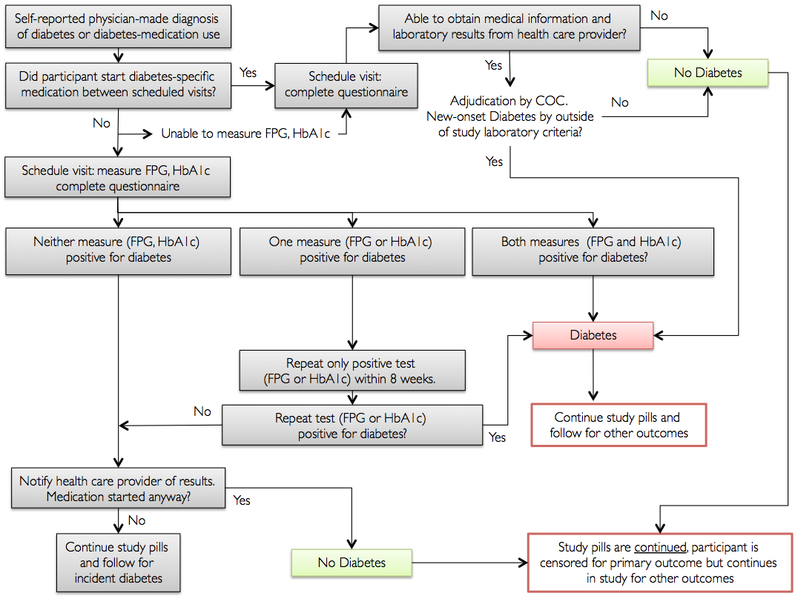

18.4 POSTPONEMENT OF GLYCEMIA TESTING

Tests for glycemia are performed without interrupting the assigned study treatment. Testing at one of the scheduled follow-up visits or confirmatory visits will be postponed for up to 8 weeks if, in the opinion of the site investigators, a temporary concomitant condition exists that would affect glucose tolerance (e.g. active infection, hospitalization which may also require temporary use of a diabetes medication, short-term use of glucocorticoids), its assessment (e.g. blood transfusion or blood donation) or for any other administrative or social reason.

18.5 DIABETES DEVELOPMENT OUTSIDE OF D2d

When a diagnosis of diabetes is made outside of D2d or if the participant plans to initiate diabetes-specific pharmacotherapy between scheduled visits, participants will return to the clinic for a visit outside the schedule to undergo glycemic testing before they start any diabetes-specific medication (see below and Figure 18.4). If testing cannot be done or the participant has started diabetes medication, the diagnosis of diabetes is adjudicated by the COC (Figure 18.4).

The following procedures will be followed by clinical site staff:

- At baseline and every visit, educate participants to contact the Research Coordinator as soon as possible after a health care provider outside of the D2d study makes the diagnosis of diabetes or if the health care provider plans to initiate diabetes-specific pharmacotherapy.

- Participants are told to hold diabetes-specific pharmacotherapy until they communicate with D2d study staff.

- This reminder is critically important so that participants return to the clinic for a visit outside the schedule to undergo testing for diabetes before they start any diabetes-specific medication.

- Participants should be given a list of diabetes medications that are not allowed during the study and the list should be reviewed at every visit.

- Diabetes-specific pharmacotherapy is defined as any FDA-approved medication for diabetes, including for uses not specific to diabetes (e.g. metformin for polycystic ovarian syndrome). A list of diabetes-specific medications is in the Appendix.
- Medications with approved indication for weight loss (e.g. Qsymia) are not considered diabetes-specific pharmacotherapy.

- Engage the participant’s primary care and other health care providers with frequent status updates (see MOP section 17 for template letters). Keeping providers informed reduces the likelihood that the participant will start pharmacotherapy before study-specific glycemic testing.

- When a participant reports that he was diagnosed with diabetes or if his health care provider plans to initiate diabetes-specific pharmacotherapy, the Non-D2d Diabetes Diagnosis worksheet (see section 18.5.1 and Appendix) will be used to collect relevant data.

- Participants will need to be contacted and be seen as soon as possible to collect relevant information and perform within-study glycemia testing to be analyzed by the Central Laboratory. Participants must be able to easily get in contact with the site Research Coordinator, either by phone or email or any other method that is preferred by participants.

- At the initial contact over the phone, participants will be asked questions related to their non-study visit and responses are entered in the Non-D2d Diabetes Diagnosis worksheet. Preliminary information collected during the phone call will determine the need for glycemia testing to be done as part of the study and whether the participant can delay starting the diabetes medication until he returns for his D2d visit outside of the study schedule.

- After the initial contact over the phone or email, a visit is scheduled as soon as possible. It is essential for the visit to take place prior to the participant starting diabetes-specific pharmacotherapy. Therefore, if medically appropriate, the participant is told not to start diabetes medication until he comes in for his visit and completes all required testing.

- Instruct the participant to bring all medications and supplements he is taking to the visit with him, including the new diabetes medication(s) and study pills.

- At the visit, if diabetes-specific pharmacotherapy has not been initiated, the participant will undergo glycemia testing for diabetes to be analyzed by the Central Laboratory, as described in section 18.3.3 and figure 18.4.

- At the visit, additional information will be obtained and recorded in the Non-D2d Diabetes Diagnosis worksheet. The information collected will be used by the COC to adjudicate the diagnosis of diabetes, if D2d-specific glycemia testing is not done.

18.5.1 Non-D2d Diabetes Diagnosis Worksheet

The following questions will be asked when a participant first reports that he has been diagnosed with diabetes outside of the study or has been prescribed diabetes specific-pharmacotherapy. Responses will be collected at the initial contact (e.g. over the phone). Questions and responses will be reviewed and additional information obtained or clarification provided during subsequent contacts, including visits.

- Please utilize the Non-D2d Diabetes Diagnosis worksheet (see Appendix) for data collection and ensure all required questions are asked during a participant contact. Start with open-ended questions and then ask specific questions to ensure all of the information required for adjudication is collected.

- Date participant reported the diagnosis of diabetes to the site or the prescribing or start of a diabetes-specific pharmacotherapy. This is the date of the first communication (phone, email etc.) when the participant notified the site that he was given the diagnosis of diabetes outside of D2d or was asked to start a diabetes-specific pharmacotherapy.

- Type of initial contact with the site. For example, telephone, email, study visit, other.

- Setting of diabetes diagnosis or prescribing of diabetes-specific medication. Indicate where the diagnosis of diabetes was made or where a diabetes-specific medication was prescribed. For example:
  - Outpatient clinic or office
    - Primary care
    - Medical-surgical specialist
  - Hospital
    - Emergency room
    - Inpatient
    - Day surgery
  - Health Screening
    - Community health fair
    - Employee health
  - Other (e.g. pharmacy). Indicate _____________

- Professional making the diagnosis of diabetes or prescribing diabetes-specific medication. Enter information about the professional who evaluated glycemic results and made the diagnosis of diabetes or who prescribed diabetes-specific medication. For example:
  - Physician
  - Nurse practitioner, physician assistant, surgical assistant
  - Nurse
  - Community health worker (lay person)
  - Pharmacist
  - Other. Indicate _____

- Be sure to record on the worksheet details related to the setting (name and address of the facility, or medical practice, etc.), who made the diagnosis or prescribed a medication (e.g. name of physician), their contact information and the date of diagnosis or prescription. This will be useful when obtaining medical records and/or sharing follow-up information.

- Date of diabetes diagnosis or prescribing of diabetes-specific medication. Indicate when the participant was tested for diabetes or given a prescription for a diabetes medication. If the participant does not remember the date, ask additional questions to help him remember or to limit the date range, e.g. if participant says the end of December, ask if it was before or after Christmas.

- Reason for testing or reason for prescribing a diabetes-specific medication. The diagnosis of diabetes can be made for a variety of reasons, e.g.
  - Routine (e.g. well visit, pre-operative testing, health screening)
  - Symptoms of diabetes (provide details)
  - Other illness or hospitalization, e.g. inpatient or emergency room (provide details)
  - Other (provide details, especially if reason for prescribing a medication was not diabetes)

- Ask open-ended questions, e.g. why were you tested for diabetes? If the participant does not know or the response is unclear, ask a more detailed or probing question, e.g. why did you go to the doctor? Were you having symptoms? What kind of symptoms?
- Provide details and/or additional information

- Diabetes-specific medication prescribed. Ask the participant if he has had any medications prescribed and whether it was for diabetes or not. If yes, for each medication collect the following:
  - Name, dose, route, frequency
  - Start date / end date
  - Reason

- The goal of this question is to determine if the participant started any diabetes-specific medication (See Appendix for list of medications approved for diabetes).

- If the participant was given prescription(s) but has not started the medication(s), reinforce with the participant the need to come in for a visit to confirm the diagnosis within the study, prior to him starting any medications.

- Changes in lifestyle. Ask the participant if he has made any changes to lifestyle (diet or physical activity) since he was told of the diagnosis of diabetes. If yes, ask the participant to provide details regarding the changes he has made, when he made them.

The sites will use information in the Non-D2d Diabetes Diagnosis worksheet to enter key information in the Diabetes Adjudication eCRF (see MOP section 15).

18.5.2 Diabetes-specific pharmacotherapy started in between study visits

If, based on the responses on the worksheet, it is determined that the participant has already started a diabetes-specific medication between study contacts, participant will still need to come in for a visit but no glycemic testing will be performed (Figure 18.4). During that visit, additional detailed data will be collected regarding the diagnosis of diabetes made outside of the study. Participants will be instructed to continue taking the study pills until the non-D2d diabetes diagnosis is adjudicated by COC. Depending on the outcome of the adjudication, participants will continue or discontinue the study pills (see Figure 18.4).

18.5.3 Retrieval of medical records

- If a diagnosis of diabetes is made outside the D2d study and there is no D2d-specific glycemic testing available (e.g. participant refusal) or participant has started taking a diabetes-specific medication and D2d glycemic testing cannot be done, then medical records need to be retrieved to adjudicate the diagnosis of diabetes.
- Ask the participant to sign a medical release form and obtain records from the health care provider(s), with special emphasis on obtaining the most recent laboratory values for FPG, HbA1c and 2hPG before any diabetes-specific medication(s) were started. Inform the participant that it is essential for the study to obtain any medical records related to the diagnosis of diabetes. Ideally, getting medical records should be done as soon as possible after the initial self-report of the diagnosis of diabetes or use of diabetes-specific medication. The medical release form – which is specific to each clinic/hospital – can be e-mailed, faxed or mailed to the participant and the participant should be instructed to return it the Research Coordinator in the most efficient and reliable way.
- If the participant has a printout of the laboratory results, ask him to bring them to the visit.
- The medical records will be reviewed and relevant information will be entered in the Non-D2d Diabetes Diagnosis worksheet.

18.5.4 Adjudication of Diagnosis of Diabetes

For every participant who was diagnosed with diabetes outside of the study and/or started diabetes-specific pharmacotherapy and no D2d glycemia data by the Central Laboratory are available, the diagnosis of diabetes will be adjudicated by the COC.

- The site Research Coordinator will send to the CC (d2d@tuftsmedicalcenter.org) copies of the completed Non-D2d Diabetes Diagnosis worksheet and all relevant medical records with all identifying information concealed or obliterated. See section 18.8 for information on submitting records to the CC and concealing identifying information from the medical records. The site PI will ensure the completeness and accuracy of the submitted data.
- The CC will review the submitted worksheet and medical records for completeness, to ensure identifying or potentially unmasking information is not showing.
- The CC will compile a Non-D2d Diabetes Adjudication file consisting of the following documents:
  - Diabetes Adjudication eCRF. The site enters information in the form and the CC verifies the information entered. If needed, sites will be asked to make corrections in the information that was entered in the Diabetes Adjudication eCRF and/or obtain additional records.
  - Relevant medical records with identifying information concealed (refer to section 18.8).
  - Non-D2d Diabetes Adjudication Review Form (see Appendix).
- As soon as the Non-D2d Diabetes Adjudication file is complete, it will be sent for review to two members of the COC.
- The COC reviewers will review the material to determine whether the outside laboratory results meet the study glycemic criteria for diabetes. During the adjudication process, the reviewers will follow, as closely as possible, the glycemic algorithms shown above (Figure 18.2 and 18.3).
- The reviewers will adjudicate the event by selecting one of the following three options:
  - Participant experienced new-onset diabetes. Date of diagnosis will be indicated.
  - Participant did not experience new-onset diabetes. If applicable, start date of diabetes-specific pharmacotherapy will be indicated.
  - Insufficient information for adjudication. If applicable, start date of diabetes-specific pharmacotherapy will be indicated.
- The reviewers will complete the Non-D2d Diabetes Adjudication Review Form and return it to the CC (d2d@tuftsmedicalcenter.org).
- Upon receipt of the Non-D2d Diabetes Adjudication Review Form from both committee members, the D2d Project Manager (or designee) will review the forms.
- If the two reviewers agree (e.g. both concluded there was insufficient information for adjudication), their assessment will be accepted as the adjudicated outcome and entered into the Diabetes Adjudication eCRF by the CC Project Manager (or designee).
- If the reviewers agree that participant developed new-onset diabetes, but there is discordance in the date of onset, a conference call will be arranged by the CC to reach consensus among the two reviewers.
- If there is discordance on the diagnosis of diabetes between the two reviewers that cannot be resolved between them, the Non-D2d Diabetes Adjudication file will be sent to another COC member who will act as the third reviewer. A majority decision will prevail. If there is discordance among all three reviewers (i.e., presence of new-onset diabetes vs. absence of new-onset diabetes vs. insufficient information), a conference call will be arranged by the CC with the goal of reaching consensus among the three reviewers. Discussion will continue until there is a consensus or a majority (i.e., 2 out of 3 reviewers) agrees on the presence of new-onset diabetes, absence of new-onset diabetes or the insufficiency of the information for adjudication. The majority judgment will be accepted as final and entered into the Diabetes Adjudication e-CRF by the CC Project Manager (or designee).
- If at any point during the adjudication process, a reviewer determines that further information is needed, the CC will work with the site staff to determine if additional information pertaining to the diagnosis of diabetes is available. If new or additional information is available, it will be obtained and incorporated into the Non-D2d Diabetes Adjudication file and the reviewers will re-evaluate the diagnosis of diabetes in the setting of the new information provided.

- Note: If laboratory data from the health care provider cannot be obtained, then the participant will be considered as not having reached the diabetes outcome and will be coded as insufficient information for adjudication.

- Consistent with the double-masked study design of the D2d study, the COC members will remain masked to study group assignment during the adjudication process.
- At each Safety and Outcomes Subcommittee (SOS) meeting, the CC will report on the number of diabetes cases that have been reviewed and adjudicated by the COC.
- The full SOS will consider improvements in the diabetes adjudication process at its regular meetings.

18.6 DATE OF DIABETES ONSET

- If the diagnosis of diabetes is made within the study (i.e., using results by the Central Laboratory), the date of onset of diabetes is defined as the date of the first diagnostic glycemic value.
- If the diagnosis of diabetes is made outside of study (i.e., adjudicated by the COC), the date of onset of diabetes will be determined during the adjudication process and will be indicated in the Non-D2d Diabetes Adjudication Review Form.

If the COC determines that participant did not experience new-onset diabetes or there is insufficient information for adjudication and the participant has started diabetes pharmacotherapy, the date of censoring for the diabetes outcome will be the date that the participant started pharmacotherapy, determined during the adjudication process and indicated in the Non-D2d Diabetes Adjudication Review Form.

18.7 MANAGEMENT OF PARTICIPANTS AFTER DIAGNOSIS OF DIABETES

After the primary outcome of diabetes has been reached on confirmatory testing or by the adjudication process, study pills will be continued and participants will be referred to their primary care physician for further care in relation to diabetes. Participants will continue in the study and return for scheduled visits until the end of the study for assessment of other outcomes.

If the participant has started diabetes-specific pharmacotherapy and the diagnosis of diabetes is not or cannot be adjudicated, or diabetes-specific pharmacotherapy is started despite the within-study testing not confirming diabetes, then the participant will be considered as not having reached the outcome. Participant will be administratively censored for the primary outcome, study pills will be continued and participant will continue in the study and complete all subsequent planned measurements and visits for other outcomes.

- After the diagnosis of diabetes is made, a letter will be sent to the participant’s primary care physician or health care provider who will manage the participant’s diabetes (see template letter in MOP section 17). The letter will:

  - Provide the results of the D2d glycemia measures diagnostic for diabetes.
  - Reinforce that the participant will continue the study pills and participating in D2d for assessment of other outcomes.
  - Inform the health care provider that:
    - Glycemic results need to be repeated in the clinical setting before the diagnosis of diabetes is established clinically.
    - The participant’s diabetes will not be managed by the study investigator /physician.

18.8 SUBMITTING RECORDS TO THE COORDINATING CENTER

Sites will send records related to a non-D2d diagnosis of diabetes to the CC using the Non-D2d Diabetes Adjudication Source Documents Coversheet (see Appendix), as follows:

- The participant’s enrollment ID must be recorded on each page sent.
- All pages should be numbered in the following format: page #/ # of pages, e.g., if 3 pages are sent, these should be numbered 1/3, 2/3, 3/3.
- Any information that could identify the participant must be concealed/obliterated.
  - Identifying information includes:
    - Name
    - Date of birth
    - Medical record, or social security number
    - Address or place of residence
    - Identifying information of family members
  - To conceal identifiers:
    - Make a copy of the source documents. Keep the original in your files
Note: the original source documents with the identifying information should not be altered. The identifiers must always be visible on the original source documents.
    - With a black Sharpie type marker or a Bic Wite-out correction tape type marker, mark/cover over all identifying information on the copy. Care must be taken to not cover non-identifying information.
    - Make a photocopy of the marked up document and review it to ensure the identifiers are not visible prior to sending it to the CC.

- Submitting any participant documents to the CC that include identifying information is a serious violation.

18.9 APPENDICES

Appendix 1. Diabetes Specific Medications

Appendix 2. Non-D2d Diabetes Adjudication Worksheet

Appendix 3. Non-D2d Diabetes Adjudication Review Form

Appendix 4. Adjudication Source Document Coversheet

