For questions regarding the
D2d study, please contact us at:
:
D2d Collaborating Clinical Sites
Arizona
NIDDK Phoenix
Phoenix, AZ
602-640-2190 ext. 205
California
Stanford University
Palo Alto, CA
(650) 721-2235
University of Southern California
Keck School of Medicine
Los Angeles, CA
(323) 361-8416
District of Columbia and Maryland
MedStar Health Research Institute
Hyattsville, MD
(301) 560-2925
Florida
Florida Hospital Translational Research Institute
Orlando, FL
(407) 303-7174
Georgia
Atlanta VA Medical Center
Atlanta, GA
(404) 321-6111, ext 6839
Illinois
Northwestern University
Chicago, IL
(312) 503-3267
Kansas
University of Kansas
Medical Center
Kansas City, KS
(913) 588-0698
Louisiana
Pennington Biomedical
Research Center
Baton Rouge, LA
(225) 763-0919
Tulane University
New Orleans, LA
(504) 988-0200

Maine
Maine Medical Center
Research Institute
Scarborough, ME
(207) 396-8057
Massachusetts
Tufts Medical Center
Boston, MA
(617) 636-2834
Minnesota
Health Partners
Research Foundation
Bloomington, MN
(612) 341-1955
Nebraska
University of Nebraska
Omaha, NE
(402) 995-3924
New York
Beth Israel Medical Center
New York, NY
(202) 420-3450
North Carolina
Duke University Medical Center
Durham, NC
(919) 620-5350
South Carolina
Medical University of South Carolina
Charleston, SC
(843) 792-5427
Tennessee
University of Tennessee
Health Science Center
Memphis, TN
(901) 448-8400
Texas
University of Texas Southwestern
Dallas, TX
(214) 648-9733
Baylor College of Medicine
Houston, TX
(713) 798-5757

Vitamin D and
type 2 diabetes
Insert Site location

Study Coordinator: xxxxxxxx
Email: xxxxx@xxxxxxx.xxxx
Phone: XXX-XXX-XXXX

Study Physician: XXXXXXXXXXXXXX
Email: xxxxx@xxxxxxx.xxxx
Phone: XXX-XXX-XXXX



Please visit www.d2dstudy.org
to meet the D2d study team,
learn more about diabetes
and vitamin D, and find out the
latest D2d study news!

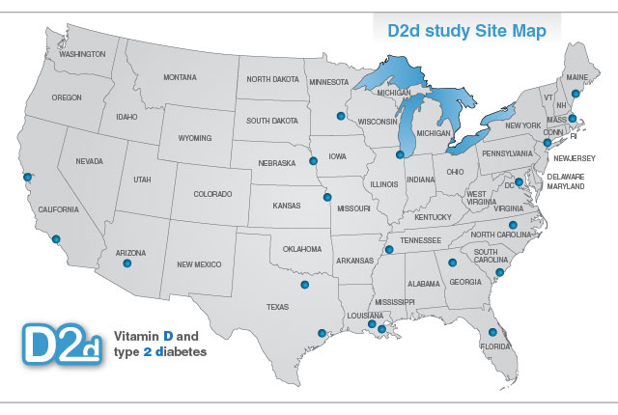
The study is sponsored by
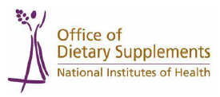
www.d2dstudy.org
CLINICAL PROVIDER INFORMATION
A randomized controlled clinical trial to evaluate the safety of vitamin D and its effect on reducing the rate of progression to diabetes in people at risk for diabetes.

Vitamin D and
type 2 diabetes
The D2d study is a multicenter, randomized, double-masked, placebo controlled, primary prevention clinical trial in participants at high risk for diabetes (pre-diabetes) who will be followed for up to 4 years after randomization for new onset diabetes.
What is the D2d Study?
The study will assess whether oral daily vitamin D supplementation reduces the rate of progression from pre-diabetes to clinical diabetes in persons at risk for diabetes.
The study is sponsored by NIH and will take place at 20 clinical sites across the US and approximately 2,400 participants will be enrolled.
Study Intervention &
Participation Involvement

Participants will be randomized to take a study pill containing vitamin D (4,000 units) or placebo daily with breakfast.
Participants will be seen at 3 months, 6 months, and then twice a year for up to 4 years to assess safety and incident diabetes.
If a participant is diagnosed with diabetes during the study, he/she will be referred to their doctor for treatment.
At baseline, participants will receive information on lifestyle modifications for prevention of type 2 diabetes. Twice a year, during the study, participants will be invited to a support and education session on the prevention of diabetes.
If you have patients who could benefit from participating in the D2d study, please have them visit the study’s website www.d2dstudy.org or call one of the collaborating clinical sites (see opposite page).

Participants will remain under the care of their primary care provider; therefore, communication between the providers and D2d study personnel is essential.
Primary Care Provider Engagement
- If a participant is diagnosed with diabetes during the study, he/she will be referred to his/her provider for further management.
- Prior to starting pharmacotherapy for diabetes, please contact the Study Coordinator (shown in the back panel).
- Participants are instructed to limit vitamin D supplementation outside of the study to no more than 1000 IU per day, and calcium supplementation to no more than 600 mg per day. If a participant needs supplementation with doses of vitamin D, or calcium greater than specified above, please notify the Study Coordinator.
- If a participant authorizes the release of protected health information, the D2d study will provide you with study-specific glycemic results, inform you of any adverse events, and may request relevant medical records.
Note: During the study, glycemic tests are analyzed in a research laboratory; therefore tests should be repeated prior to making any clinical decisions
Inclusion Criteria

1. Age ≥ 30 years
2. Pre-diabetes defined by meeting 2 out of 3 of the following glycemic criteria:
  - Fasting glucose 100-125 mg/dL
  - 2-hour glucose 140-199 mg/dL
  - Hemoglobin A1c 5.7-6.4%
3. BMI ≥ 25 (23 for Asians) and ≤ 40 kg/m²

- Recent (1 year) history of hypoglycemic pharmacotherapy or meeting glycemic criteria for diabetes
Major Exclusion Criteria
- Any medical condition (past 3 years) that may increase risk for nephrolithiasis or hypercalcemia
- Use of supplements containing vitamin D at total doses higher than 1000 IU/day
- Use of supplements containing calcium at total doses higher than 600 mg/day
- Use of thiazide diuretic > 37.5 mg/day
- Use of anticonvulsant drugs started within 6 months of screening
- Symptomatic cardiovascular disease
- History (past 1 year) of MI, PCI, CABG, or cerebrovascular disease
- Cancer (past 5 years) except for thyroid cancer
- Disease likely to require glucocorticoid therapy
- History of bariatric surgery
- Recent (1 year) history of FDA-approved pharmacotherapy for weight management
- Pregnancy over the past year
- Currently breastfeeding
- Uncontrolled hypertension (systolic BP > 160 mm Hg or diastolic BP > 100 mm Hg)
- Serum liver transaminases higher than 3 times the normal range
- Anemia or other condition rendering Hemoglobin A1c results unreliable
- Low platelet count (< 50,000)
- Chronic kidney disease
- Hypercalcemia or Hypercalciuria

