
Manual of Procedures (MOP)
Section 15. Data Management
Table of Contents
15.1 Electronic data capture (EDC) System Overview 3
15.2 Access to the EDC system 3
15.3 EDC system security 6
15.3.1 User Names and Passwords 6
15.3.2 Inactivity Timeouts 6
15.4 EDC HelP desk information 6
15.5 USER ROLES 7
15.5.1 Principal Investigator 7
15.5.2 Research Coordinator 7
15.5.3 Research Assistant 7
15.6 ENTERING DATA WITHIN THE EDC SYSTEM 7
15.6.1 Adding a New Participant 7
15.6.2 Participant Homepage 8
15.6.3 Entering Data 9
15.6.4 Entering Data on Log Forms 9
15.6.5 Add Event Forms 10
15.6.6 Editing Data 10
15.6.7 Investigator Sign-off 10
15.7 EDC QUERIES 12
15.7.1 System Queries 12
15.7.2 Manual Queries 13
15.7.3 General Guidelines on Query Response 13
15.8 EDC ICON KEY 13
15.9 eCRF FORMS 14
15.9.1 Form and Visit Summary Table 15
15.9.2 Form Descriptions 16
15.9.2.1 Visit Date 16
15.9.2.2 Consent and Enrollment 16
15.9.2.3 Screening Inclusion Exclusion Criteria 16
15.9.2.4 Baseline Inclusion Exclusion Criteria 16
15.9.2.5 Visit Other Data 16
15.9.2.6 Vital Signs 17
15.9.2.7 Medical History 17
15.9.2.8 Physical Examination 17
15.9.2.9 Concomitant Medications 17
15.9.2.10 Local Laboratory 17
15.9.2.11 Safety Local Laboratory 18
15.9.2.12 Central Laboratory 18
15.9.2.13 Central Laboratory Upload 18
15.9.2.14 Physical Activity Questionnaire 18
15.9.2.15 Study Pill Distribution 19
15.9.2.16 Discontinuation of Study Pills 19
15.9.2.17 Scheduled Contact 19
15.9.2.18 Call Log / Contact Follow-up Log 19
15.9.2.19 Study Completion 19
15.9.2.20 Adverse Event 19
15.9.2.21 Diabetes Adjudication 20
15.9.2.22 Diabetes Outcome 21
15.10 APPENDICES 22
Appendix 1 Account Activation Form 22
Appendix 2 Sample e-CRFs and Completion Guidelines 22

15.1 Electronic data capture (EDC) System Overview

The D2d study will collect data electronically from collaborating clinical sites and the central laboratory via Medidata Rave, a web based electronic data capture (EDC) system. Rave is a 21 CFR Part 11 compliant EDC system. It provides the D2d study with the ability to collect, clean, monitor, and review data, and run reports on an ongoing basis with the ultimate aim of efficient data locking at study completion, followed by swift data analyses.

15.2 Access to the EDC system

Access to the EDC system will be granted to qualified research staff who need to enter or view data. All users must complete training specific to their role (i.e., research coordinator, research assistant, principal investigator) prior to being granted access. For all users, training will consist of completing the iMedidata training module specific to the role, unless a user can demonstrate that he has completed Medidata training in the past (see below). Additional specific training on case report forms will be required of research coordinators and research assistants that do data entry. Training will take place at the first investigators meeting and via webinar. Additional training may be scheduled as needed during the study.

To obtain access to the EDC system and complete the required online training:

1. Download the Account Activation Training form from the D2d study portal (www.D2dstudy.org) from the “Other Documents” menu item. Complete and submit to the D2d Coordinating Center (CC) by email (d2d@tuftsmedicalcenter.org).

Note: If you have previously completed a Rave/Medidata training course (eLearning, Webinar, Instructor Led), you must indicate so in the Account Activation Training Form and attach the certificate to the form.

2. The CC will review the information on the Account Activation Training form. Soon after the CC grants approval, Medidata will send an automatic email, inviting the user to the D2d study.
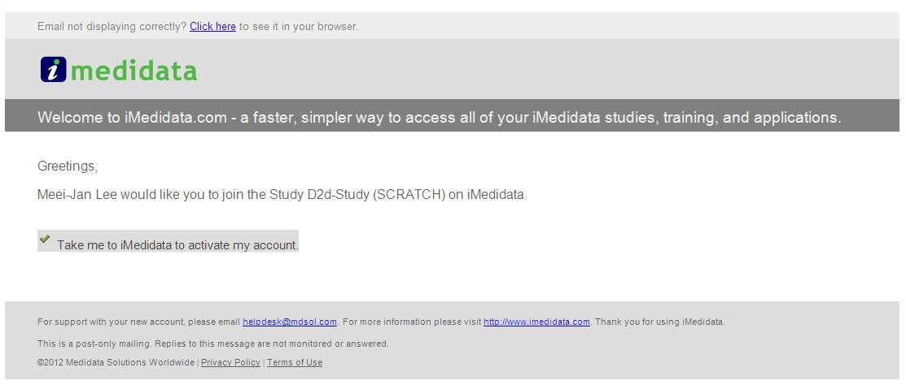
Click on this link

3. After selecting “Take me to iMedidata to activate my account,” a registration page will display. Complete all required fields and click “Activate.”
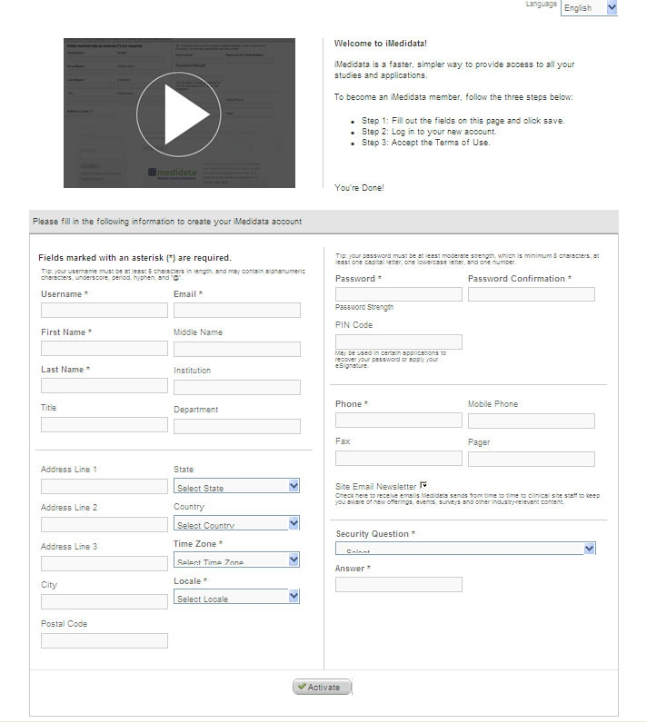

4. After completing the registration page, the user will then be directed the main Medidata login page to log in using the newly created username and password.
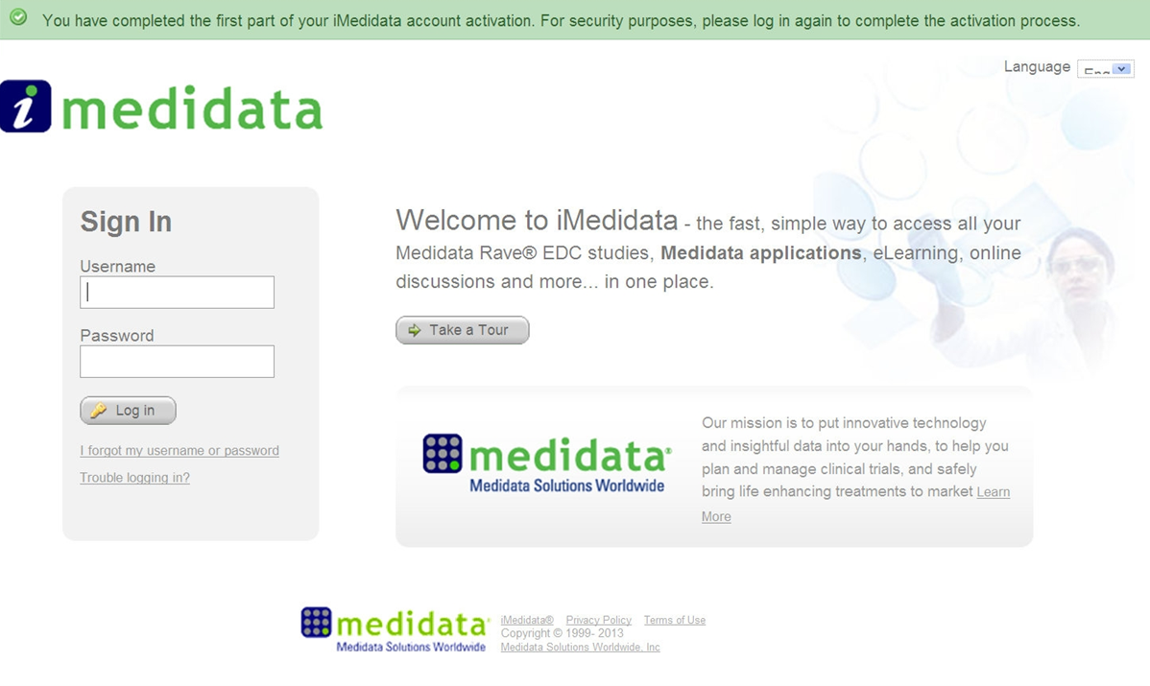
5. The user’s iMedidata account is automatically programmed with the eLearning course requirement for the user role (e.g. RC, PI). When the user first logs on, iMedidata will check the user’s record to see if the user has completed the required Rave/Medidata training. If not, iMedidata will not allow user to gain access to the D2d study until the user completes the eLearning course. Follow the link on the right side of the screen to access the online training modules.

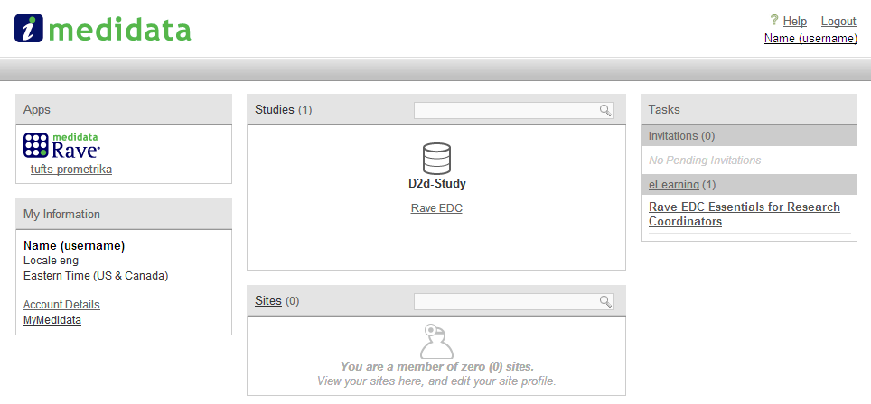

15.3 EDC system security

15.3.1 User Names and Passwords

Upon initial login, each user will be prompted to create a unique username and password. Passwords must be at least 8 characters in length and must contain an uppercase letter, a lower case letter, and a number. Passwords will be valid for 90 days and can only be reused after 365 days.

A link on the login page can be used for password recovery if the user forgot his password.
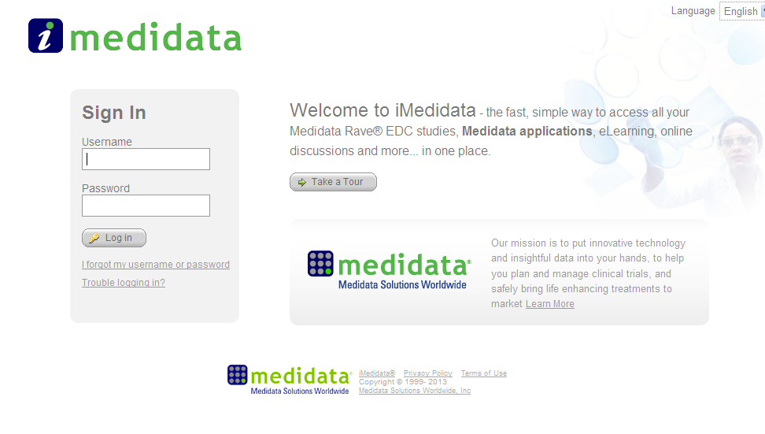
Usernames and passwords must not be shared. Any violation of this could result in termination of the user’s access.

15.3.2 Inactivity Timeouts

A password “time out” occurs if a user is inactive on the system for 30 minutes. If the user tries to submit data after being inactive for 30 minutes the system will require re-entry of the user password. If the user is inactive for 60 minutes she will be required to re-login to the system.

15.4 EDC HelP desk information

The Medidata Helpdesk is available for questions 24x7 to assist users with non-protocol system-specific issues. The Helpdesk can be reached at toll-free number 866-633-4328 or by sending an e-mail to helpdesk@mdsol.com.

The D2d study protocol number is: D2d
The D2d study URL is: tufts-prometrika.mdsol.com

The Help Desk should not be contacted for help specific to the D2d electronic case report forms. Questions about the case report form completion should be directed to the CC.

15.5 USER ROLES

Outlined below is a brief description of each of the user roles and their capabilities. If you believe there has been an error with your assigned role, please contact the D2d CC at D2d@tuftsmedicalcenter.org

15.5.1 Principal Investigator

The Principal Investigator can add participants, enter data, and respond to queries. The Principal Investigator role also has the ability to sign forms (see MOP section 15.6.7 for detailed instructions on EDC sign-off). When the Investigator signs a form, it documents that he/she reviewed the data entered on the form and agrees with it. The following forms need to be reviewed by an investigator during the study:
- Screening Inclusion Exclusion Criteria form
These forms should be signed after the baseline visit and before the randomization visit
- Baseline Inclusion Exclusion Criteria form
- Adverse Event form – if an adverse event is serious, it must be signed before the supporting documents are submitted to the CC. Non-serious adverse events should be reviewed and signed by the investigator once a month or at the time of D2d CC request.

15.5.2 Research Coordinator

The Research Coordinator can add participants, enter data, and respond to queries.

15.5.3 Research Assistant

The Research Assistant, like the Research Coordinator can enter data and respond to queries, but cannot add new participants to the database.

15.6 ENTERING DATA WITHIN THE EDC SYSTEM

Every participant that signs an informed consent form and is seen for a screening visit will be entered into the EDC system.

15.6.1 Adding a New Participant

To add a new participant, the user must first click on the Add Subject link on the main page. Enter the participant’s initials and click Save. EDC will generate the 6-digit Enrollment ID. Once this form is submitted, the participant is added to the database. A transient pop-up window appears confirming that the user has successfully added the participant.
Note: the 6-digit Enrollment ID generated by the system is the number that will be used to identify this participant for the remainder of the study.
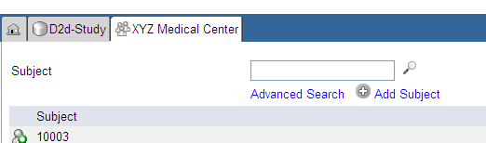

15.6.2 Participant Homepage

Once the participant has been successfully entered, the Participant Homepage opens. The participant’s Enrollment ID will always be visible in a tab at the top of the page. On the left side of the screen is a side bar that shows available folders and forms.
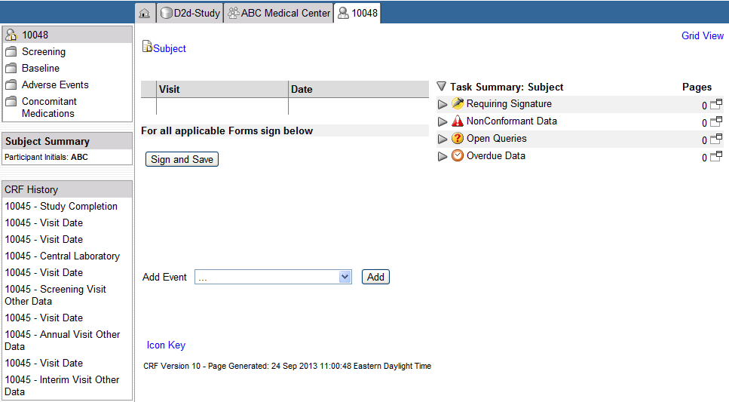

If a participant is randomized, additional folders will appear for the follow-up visits. On the right half of the screen is the Task Summary. The Task Summary lists categories of tasks needing to be completed for the participant. Each category can be expanded to see all of the required tasks.

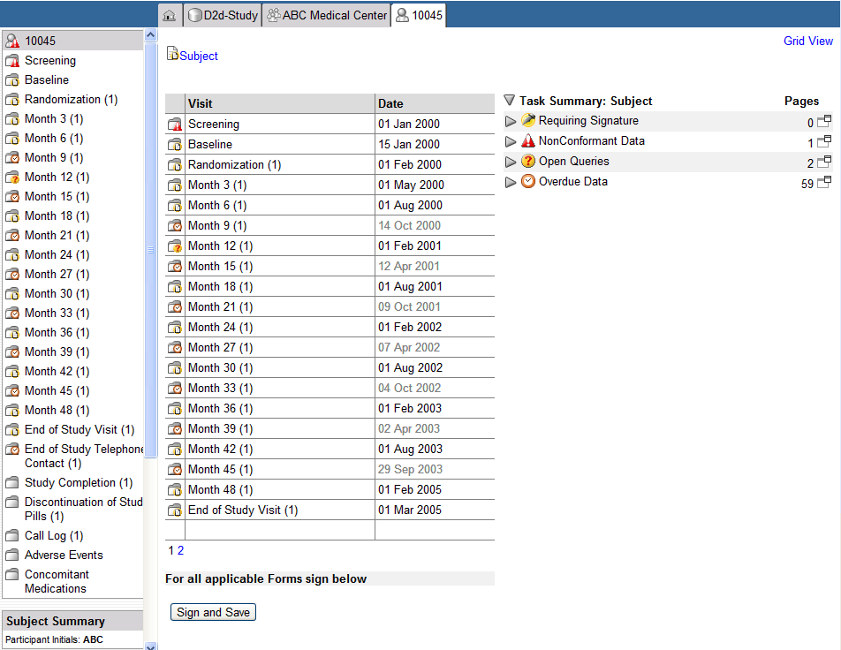

15.6.3 Entering Data

Data should be entered as soon as possible after it is collected. All data from a visit is expected to be entered within 2 business days of the visit.

To enter data, access a form by clicking on the desired folder. When a folder is selected, the first form within that folder opens in the main area with the data fields accessible for data entry. Once all data has been entered, click the Save button to save the information or Cancel button to close the form without saving the data.

Upon saving data, fields that are blank or have a query will be highlighted pink. Users should review the highlighted fields and correct data entry errors or respond to queries (if possible) prior to moving to the next form.

Many of the data entry fields have a 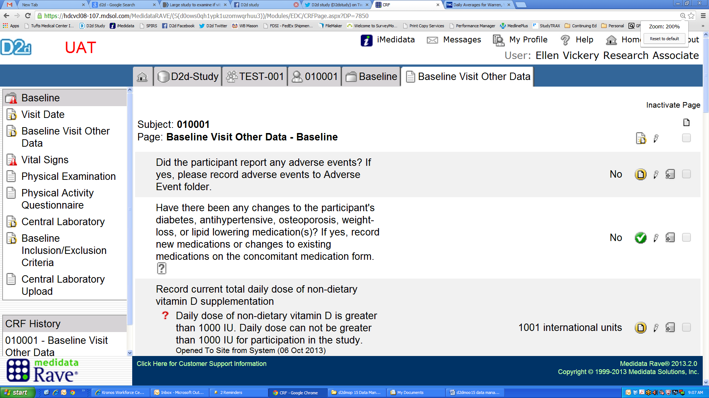 icon at the end of the question. Clicking on the icon will provide help on how the field should be completed.

Entering Times

All times are to be entered according to the 24-hour clock (military time notation). Leading zeros should be used for single digit hours.

12:05 am = 00:05 12:00 pm = 12:00
12:30 am = 00:30 12:30 pm = 12:30
12:45 am = 00:45 12:45 pm = 12:45
1:00 am = 01:00 1:00 pm = 13:00
2:00 am = 02:00 2:00 pm = 14:00
6:00 am = 06:00 6:00 pm = 18:00
8:00 am = 08:00 8:00 pm = 20:00
9:00 am = 09:00 9:00 pm = 21:00
10:00 am = 10:00 10:00 pm = 22:00
11:00 am = 11:00 11:00 pm = 23:00
(noon) 12:00 pm = 12:00 (midnight) 12:00 am = 24:00

Entering Dates

Dates should be entered by entering two numbers for the day, using the dropdown menu to select the month, and entering four numbers for the year. If the day is not known, enter UN for the day and continue by entering the month and year, however UN can only be utilized on the Medical History and Concomitant Medication forms.
Example: September 4, 1950 = 04 SEP 1950

15.6.4 Entering Data on Log Forms

A log form is used to add additional records or entries, as they are needed, to one form. Each entry on a log form is referred to as a log line. For this study, the log forms are: Concomitant Medications Form, Contact Follow-up Log, and Adverse Event Form.

As needed, users can enter additional log lines into the form by clicking Add a new log line. Users can also inactivate previously entered data by clicking on Inactivate, and choosing the line number to inactivate. The data will not disappear from the form, but instead will be lined through.

15.6.5 Add Event Forms

“Add Event” forms are forms that are not required for each participant, but may need to be added for participants (e.g. an Unscheduled Confirmatory Visit) to document specific data. The Add Event forms for this study are:
- Unscheduled/Confirmatory Visit
- Diabetes Outcomes
- Diabetes Adjudication

To add one of these forms, utilize the Add Event dropdown on the participant homepage and select the form. The form will then appear on the left side of the screen with the other forms.

15.6.6 Editing Data

Data that has been submitted can be changed or edited. Open the form to be edited and click on the Edit Pencil icon (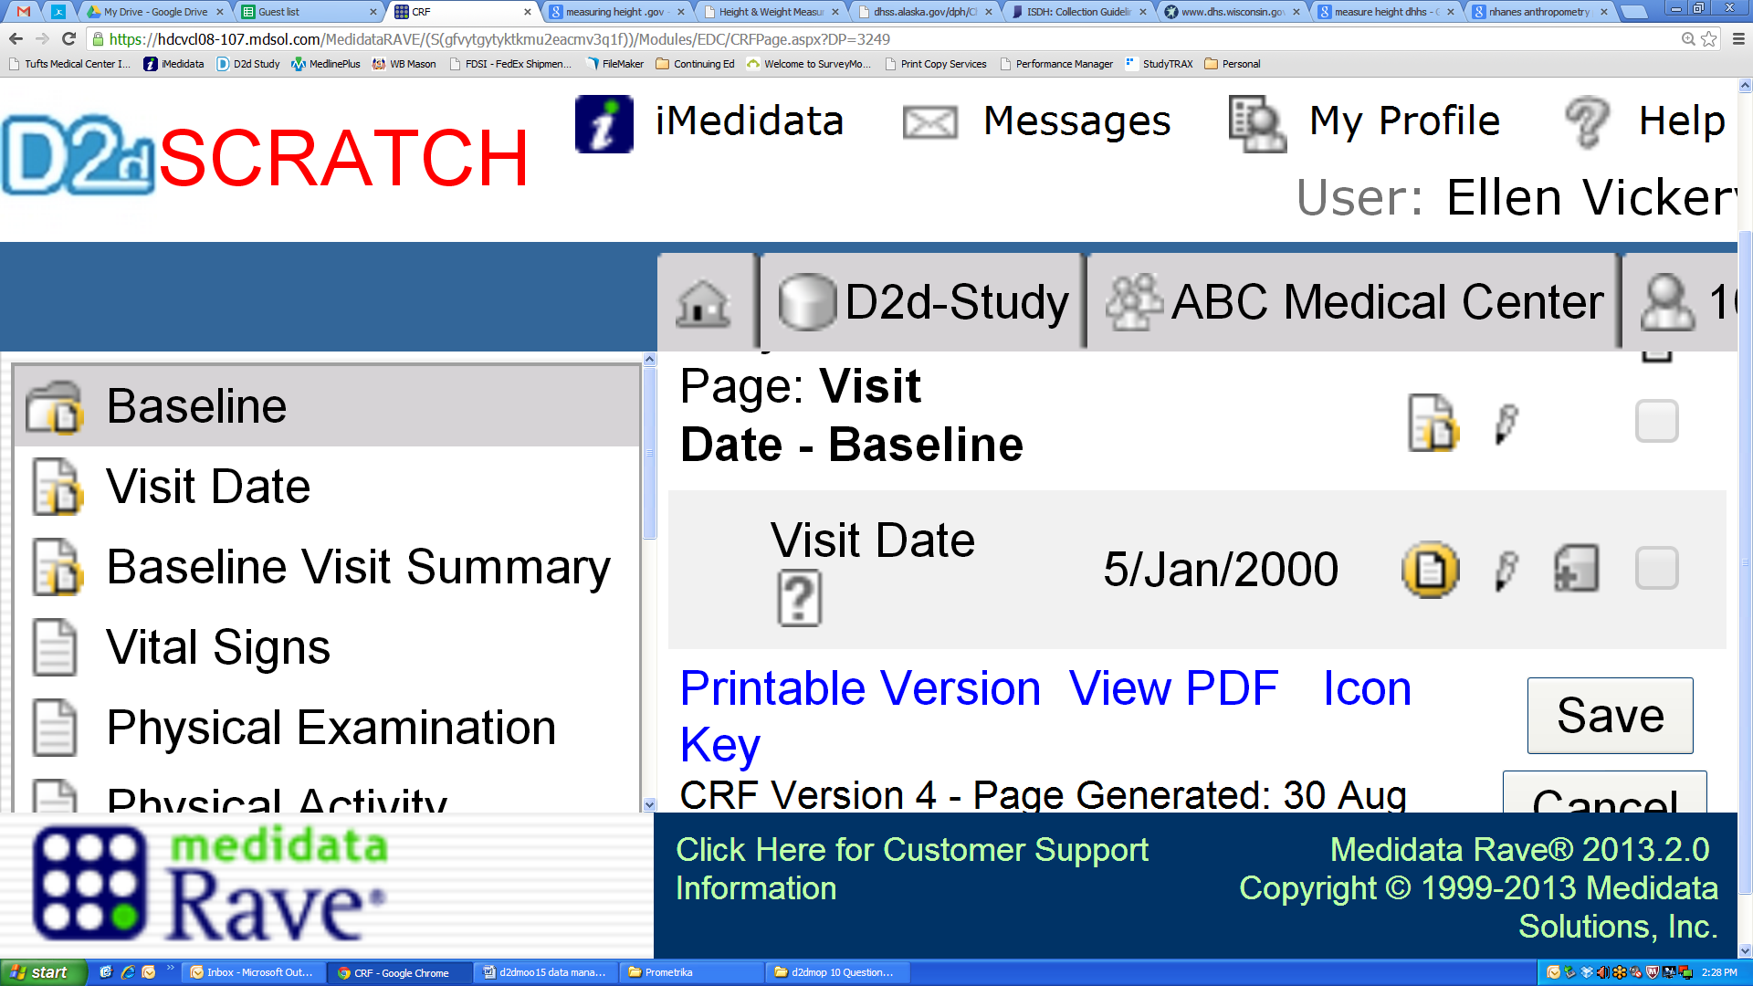) on the far right of the data field to be edited. To edit multiple fields in a form at one time, select the pencil icon at the top right of the form. This will cause the form to “reload” with the data entry field open on the selected field for editing.

A dropdown list containing reasons for changing data will appear. Selecting the reason for the change is required for the edit to be accepted. Click the Save button to save the information or Cancel button to close the form without saving the data.

15.6.7 Investigator Sign-off
The following forms need to be reviewed and electronically signed off by an investigator during the study. The Research Coordinator should specify to the Investigator which participants to sign off on (the investigator’s task summary does not filter by eligibility status):
- Screening Inclusion Exclusion Criteria form
These forms should be signed after the baseline visit and before the randomization visit
- Baseline Inclusion Exclusion Criteria form
- Adverse Event form – if an adverse event is serious or unanticipated, it must be signed before the supporting documents are submitted to the CC. Non-serious adverse events should be reviewed and signed by the investigator once a month or at the time of D2d CC request.

Steps for Sign-off
1. 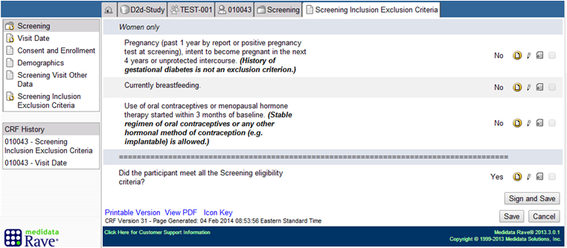
When an Investigator opens the Inclusion/Exclusion Criteria forms, the “Sign and Save” button is visible

2. Investigator is prompted to provide their log in credentials.
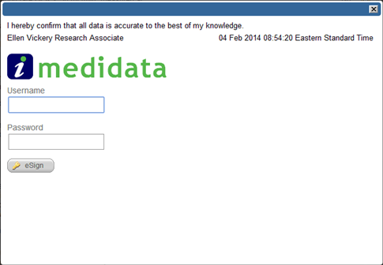
Investigators sign off on the form by entering their EDC log in information. This serves as their e-signature.

3. Confirmation that sign off completed.
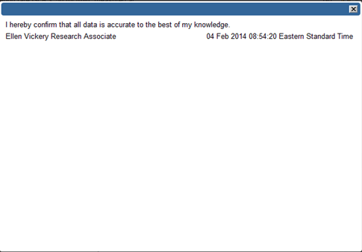
After clicking the “eSign” button, this message pops up, confirming the sign off was successful.

Verifying Sign-off Complete
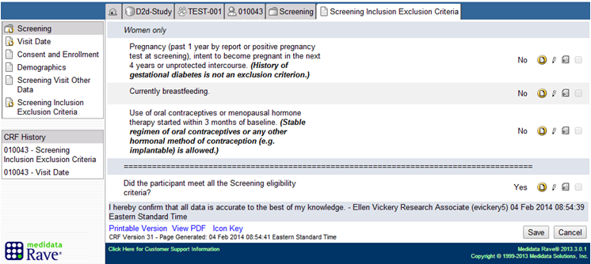
Once a form has been signed-off on, this statement appears at the bottom of the page. This is how the RC will know if a form has been signed.

15.7 EDC QUERIES

15.7.1 System Queries

The EDC has a number of built in data checks (system queries). The system checks for data that is out of the expected range or is entered in an incorrect format. In addition, the system can compare data entered in one field or form to data in another field or form for consistency. If the system identifies an issue with data in a field an automatic system query is triggered. When a system query is triggered, the field will be highlighted pink on the screen to alert the user. In addition, the number of open (unresolved) queries will be listed in the Task Summary box on the participant’s homepage in the EDC system. Site users can address queries in two ways: if the data is incorrect, the correct information should be entered and the reason for change selected, which will close the query, or, if the data is correct as entered, the query text box can be utilized to provide explanation.

Note: If data was entered incorrectly, change the data to the correct information and do not type an explanation.

Once the data is fixed and/or a required response has been entered, the system query will close to the user automatically. However, if no response can be entered the system query will not close. A Research Associate at the CC will review and close the query.

Users should review and try to resolve queries as they are generated or as data becomes available. Twice a month the CC Research Associate will send an email to the Research Coordinator with a detailed listing of open queries and a request to respond to them.

15.7.2 Manual Queries

Manual Queries are generated by the Research Associates at the CC on a data field. They will appear the same as system queries and should be responded to in the same manner as the system queries. The e-CRF that contains the query should be opened and corrections to the data should be made, if appropriate, and the e-CRF saved as above. The CC Research Associate will close the query.

15.7.3 General Guidelines on Query Response

In general, a query should only be responded to when the data issue is taken care of. For example, if the waist circumference measurement was missed at the baseline visit, but will be measured at the randomization visit, leave the query open and un-answered. Fill in the data when it is available and the query will close automatically.

15.8 EDC ICON KEY

The Rave system uses icons to alert the user. The Icon Key (below) may be accessed by clicking on the link on the site or participant homepage.
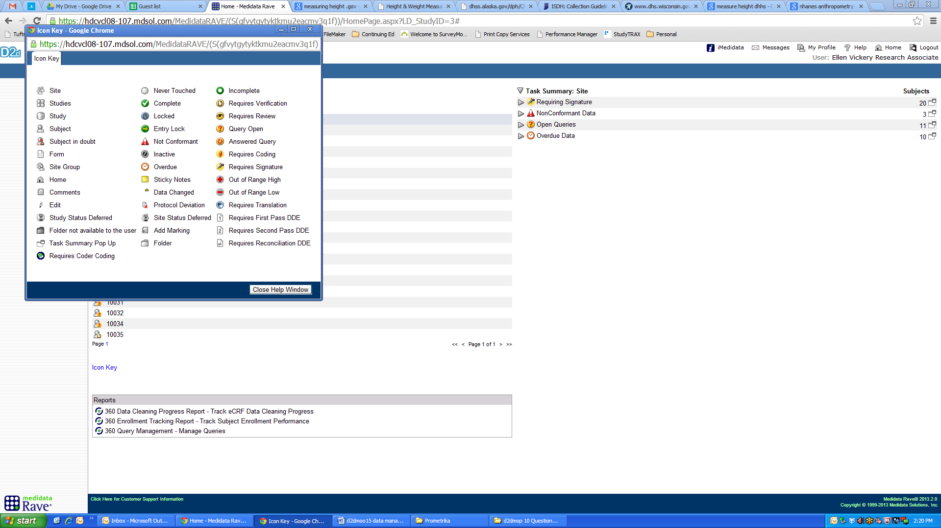

15.9 eCRF FORMS

The EDC system is organized by visits. Each visit has its own folder. Within each folder, there are individual data collection forms.

Below are descriptions of the D2d eCRFs, with the actual forms shown in the appendix. The same form maybe used at many visits. However, at some visits some data fields are not needed and will be hidden. When looking at the actual forms in the appendix, fields that are required only at some encounters are noted.

15.9.1 Form and Visit Summary Table

Visit  Form |  | Screening |  | Baseline | Randomization | Month 03 |  | Month 06 | Annual (M12, M24, M36, M48) | Semi-annual (M18, M30, M42) | Unscheduled Confirmatory |  | End of Study | Interim Phone (M9, M15, M21, M27, M33, M39, M45) | EoS Phone
Visit Date |  | ✓ |  | ✓ | ✓ | ✓ |  | ✓ | ✓ | ✓ | ✓ |  | ✓
Consent and Enrollment |  | ✓
Screening Inclusion Exclusion Criteria |  | ✓*
Baseline Inclusion/Exclusion Criteria |  |  |  | ✓*
Demographics |  | ✓
Visit Other Data |  | ✓ |  | ✓ |  | ✓ |  | ✓ | ✓ | ✓ | ✓ |  | ✓
Vital Signs |  | ✓ |  | ✓ |  | ✓ |  | ✓ | ✓ | ✓ | ○ |  | ✓
Medical History |  | ✓ |  | ○ |  | ○ |  | ○ | ○ | ○ | ○ |  | ✓
Physical Examination |  |  |  | ✓ |  | ○ |  | ○ | ○ | ○ | ○ |  | ✓
Concomitant Medications |  | ✓ |  | ✓ |  | ✓ |  | ✓ | ✓ | ✓ | ✓ |  | ✓ | ✓
Screening Local Laboratory |  | ✓
Safety Local Laboratory |  |  |  |  |  | ✓ |  |  | ✓ |  | ○
Baseline and Annual Central Laboratory |  |  |  | ✓ |  |  |  |  | ✓
M03 Central Laboratory |  |  |  |  |  | ✓
Semi Annual Central Laboratory |  |  |  |  |  |  |  | ✓ |  | ✓
Central Laboratory Confirmatory Tests |  |  |  |  |  |  |  |  |  |  | ○
Physical Activity Questionnaire |  |  |  | ✓ |  |  |  | ✓ | ✓
Study Pill Distribution |  |  |  |  | ✓ |  |  | ✓ | ✓ | ✓ | ○ |  | ✓
Discontinuation of Study Pills^ |  |  |  |  |  |  |  |  |  |  |  |  | ✓
Scheduled Contact |  |  |  |  |  |  |  |  |  |  |  |  |  | ✓ | ✓
Study Completion^{Δ} |  |  |  |  |  |  |  |  |  |  |  |  |  |  | ✓
Adverse Event |  | ○* |  | ○* | ○* | ○* |  | ○* | ○* | ○* | ○* |  | ○* | ○* | ○*
Diabetes Adjudication |  |  |  |  |  | ○ |  | ○ | ○ | ○ | ○ |  | ○
Diabetes Outcome |  |  |  |  |  | ○ |  | ○ | ○ | ○ | ○ |  | ○
✓ = required | ○ = as needed |  | * = Investigator review required |  |  |  | ^Completed at the End of Study visit, or earlier if study pills are permanently discontinued or consent is withdrawn |  |  |  |  | ^{Δ}Completed after the End of Study Phone contact or if participant withdraws consent

15.9.2 Form Descriptions

15.9.2.1 Visit Date

The Visit Date form appears as the first form of all visits. The visit date field must be completed before entering any other data from that visit.

15.9.2.2 Consent and Enrollment

The Consent and Enrollment form appears at screening. Other fields within EDC cross-check against the data entered on this form.

15.9.2.3 Screening Inclusion Exclusion Criteria

The Screening Inclusion Exclusion Criteria form appears at the Screening visit only. This form is intended to document if the participant meets the eligibility criteria to proceed to the baseline visit. The final question on the form “Did the participant meet all the Screening eligibility criteria?” should only be answered yes if all inclusion criteria questions were answered yes and all exclusion criteria questions were answered no (or not applicable). The participant is only eligible to continue to the Baseline visit if this is true.

15.9.2.4 Baseline Inclusion Exclusion Criteria

The Baseline Inclusion Exclusion Criteria form appears at the Baseline visit only. This form is intended to document if the participant meets the eligibility criteria and is eligible to be enrolled. The final question on the form “Did the participant meet all the Baseline eligibility criteria?” should only be answered yes if the inclusion criteria question was answered yes and the exclusion criteria question was answered no. The participant is only eligible to be randomized if this is true. Once it is determined that a participant is eligible to be randomized, the site PI or co-I should go in to EDC to sign off on the Screening Inclusion Exclusion Criteria and Baseline Inclusion Exclusion Criteria forms.

15.9.2.5 Visit Other Data

The Visit Other Data form serves two purposes: 1. Captures visit-specific data that does not fall into other data collection categories, 2: Generates corresponding forms as needed (e.g. If “Was a physical examination performed?” is answered yes, the Physical Examination form will appear in the visit folder). There are six distinct Visit Other Data forms, but all are similar in purpose and content:
- Screening Visit Other Data
- Baseline Visit Other Data
- M03 Visit Other Data
- Interim Visit Other Data
- Annual Visit Other Data
- Unscheduled-Confirmatory Other Data

15.9.2.6 Vital Signs

The Vital Signs form captures height, weight, blood pressure, heart rate, and, at the baseline visit, waist circumference.

15.9.2.7 Medical History

The Medical History form is a landscape log form, and a log line should be added for each unique medical history finding. A complete medical history is required at the screening visit and the form can be generated by answering yes to the question “Was the medical history completed?” After screening, if the medical history form requires updating (e.g. an illness reported at baseline resolves), the Medical History form within the screening folder should be updated. A complete review of medical history is again required [at the End of Study Visit] and the form should be updated if necessary.

15.9.2.8 Physical Examination

A complete physical examination is required at Baseline and the End of Study visit, so this form appears by default at these two encounters. At all other visits, if a symptom directed physical examination is done based on participant report, the form can be generated for that encounter by answering yes to the question “Was a physical examination performed?” on the Visit Other Data form.

15.9.2.9 Concomitant Medications

The Concomitant Medications form is used to collect concomitant medications a participant is taking that fall into one of the following categories:
- Hypertension medications
- Osteoporosis medications
- Weight-loss medications
- Cholesterol or lipid lowering medications
- Diabetes medications

See MOP sections 8.5.2.1 and 18 for a list of medications. All medications must be recorded using the generic (not brand name). To add a new medication, select “Add a new Log line.” The form should be reviewed at each participant visit and updated as needed.

Reference link for searching generic names: http://www.nlm.nih.gov/medlineplus/druginformation.html

15.9.2.10 Local Laboratory

The Local Laboratory form appears at the Screening visit only. This form is used to collect the laboratory results of the local laboratory panel completed at screening to determine participant eligibility.

15.9.2.11 Safety Local Laboratory

The Safety Local Laboratory form appears at the month 3 and annual visits. This form is used to enter the laboratory results of the safety labs (serum calcium, serum creatinine, and pregnancy test) performed locally. The form can also be generated at an Unscheduled-Confirmatory visit by answering yes to the question “Were safety laboratory tests collected?”

15.9.2.12 Central Laboratory

The Central Laboratory form appears at all visits where samples are shipped to the Central Laboratory. There are four distinct Central Laboratory forms, but they are similar in content, differing only by the draws required at a particular visit:
- Central Laboratory – at baseline, annual (M12, M24, M36, M48), and end of study visits
- M03 Central Laboratory
- Semi-Annual Central Laboratory – at semi-annual visits (M6, M18, M30, M42)
- Central Laboratory Confirmatory – at the Unscheduled-Confirmatory visit

15.9.2.13 Central Laboratory Upload

The Central Laboratory Upload form will display results from the Central Laboratory. In the baseline folder the form will populate with the urine calcium creatinine ratio (UCACR), HbA1c, fasting plasma glucose (GLU0) and the 120 minute plasma glucose (GLU120) results.

At subsequent visits, the results of the glycemia tests will not be visible unless the participant has met the study criteria for the diabetes outcome or started a diabetes-specific medication and had the outcome adjudicated (see sections 15.9.2.21 and 15.9.2.22). After the Central Laboratory analyzes each glycemia test (HbA1c, FPG, Glucose120), an email for each test will be sent to the RC and PI reporting if the test results are positive or negative for diabetes per the D2d study criteria (see the samples below). The RC should, after reviewing the emails, follow the algorithm in MOP section 18.

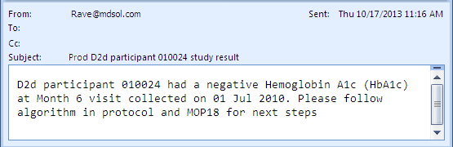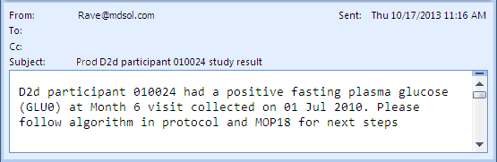

Note: the email sender address is “Rave@mdsol.com.” Add this address to your contact list to ensure these emails do not get sent to your junk box.

15.9.2.14 Physical Activity Questionnaire

The Physical Activity Questionnaire Form matches the International Physical Activity Questionnaire (IPAQ). The participant will complete the questionnaire using a paper copy of the form and her responses are transcribed from the paper copy into the e-CRF (the paper copy will remain in the participant’s source document folder). The Research Coordinator should look over the paper copy before the participant leaves in case any fields are accidentally left blank.

15.9.2.15 Study Pill Distribution

The Study Pill Distribution form appears at all visits where D2d Study Pills are either distributed or collected. This form should be completed in real time, while the participant is still in the clinic, to calculate the study pill rate of adherence. The adherence rate should be used as a trigger to provide positive reinforcement for excellent adherence or if adherence is less than 80% to counsel the participant on improving adherence and to investigate the barriers to improved adherence.

15.9.2.16 Discontinuation of Study Pills

The Discontinuation of Study Pills form is completed when study pills are permanently discontinued for a participant. In most cases, this will be at the End of Study visit. However, if the study pills are discontinued early due to the participant withdrawing consent or for a safety reason, the form will be completed at that time.

15.9.2.17 Scheduled Contact

The Scheduled Contact form is the data collection form used for scheduled phone contacts between visits (e.g. M09, M15, etc.) and for the End of Study Telephone Contact.

15.9.2.18 Call Log / Contact Follow-up Log

The Contact Follow-up Log is an optional form used to track attempts to contact a participant. If it is not used, source documents must contain documentation of all attempts to contact a participant.

15.9.2.19 Study Completion

The Study Completion form is completed when a participant’s participation in the study ends either because they completed the study per protocol or they withdrew early. Please note that “lost to follow-up” option is only utilized at the very end of the study and that attempts to contact hard to reach participants should continue until the end of follow-up is announced.

15.9.2.20 Adverse Event

The Adverse Event form is a log form and collects all adverse event records in a single form. Adverse event data should be entered as soon as possible after learning of an event and the form updated as additional information becomes available. The bottom of the form is completed by the CC Safety and Outcomes Subcommittee if the event is serious or an unanticipated problem. See MOP section 14 for more information about adverse event reporting.

15.9.2.21 Diabetes Adjudication

The Diabetes Adjudication form is completed when:
- a participant is diagnosed with diabetes outside of the study and starts a diabetes-specific medication between D2d visits
or
- a participant starts diabetes-specific medications for a non-diabetes indication between D2d visits.
To generate this form, navigate to the participant homepage. At the bottom, there is an option to “Add Event.” Select the form from the drop down list and the form will appear in the folder list on the left side of the screen. The site completes the first half of the form and sends the participant records to the CC for Clinical Outcomes Committee (COC) for review. After the COC adjudication is complete, the CC completes the bottom of the form. The CC with then notify the site RC to review the form and complete the Diabetes Outcome form. The flow chart below illustrates the use of this form.

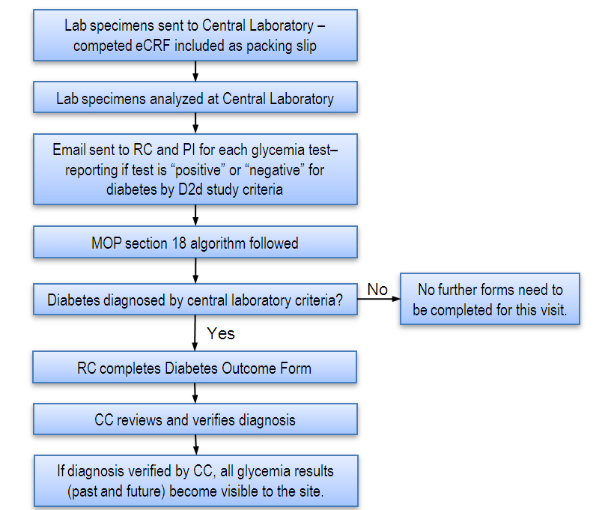

15.9.2.22 Diabetes Outcome

The Diabetes Outcome form is completed when a participant is confirmed as having diabetes by Central Laboratory testing or after COC adjudication. This form is generated from the “Add Event” dropdown on the participant home page. Completion of this form will be verified by the CC, after which the glycemia results from all past and future visits will be visible. The flow sheet below illustrates the use of this form.
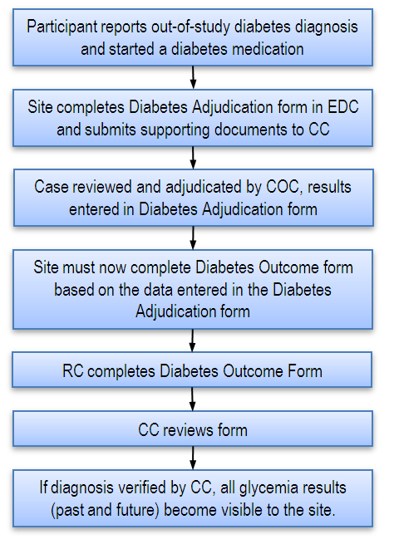

15.10 APPENDICES

Appendix 1 Account Activation Form

Appendix 2 Sample e-CRFs and Completion Guidelines

