Data and Safety Monitoring Plan

Version 4
July 25, 2013

Vitamin D and type 2 diabetes



ClinicalTrials.gov Registration Number – TBD
Funding: NIDDK
Implementation Phase: U01DK098245

Principal Investigator: Anastassios G. Pittas, MD MS
NIDDK Project Scientist: Myrlene Staten, MD
NIDDK Program Official: Saul Malozowski, MD

CONFIDENTIAL

Prepared by the D2d Coordinating Center
Division of Endocrinology, Diabetes, and Metabolism at Tufts Medical Center
800 Washington Street, Box #268 | Boston | MA 02111
www.d2dstudy.org | Facebook/d2dstudy | Twitter/d2dstudy
d2d@tuftsmedicalcenter.org | Tel 617-636-3232 | Fax 617-636-8960
Table of Contents
1. STUDY OVERVIEW 3
2. RISKS TO SUBJECTS 3
2.1 Adverse Events 3
2.1.1 Definition & Classification of Adverse Events 3
2.1.2 Definition of Unanticipated Problem 5
3. RISK BENEFIT ANALYSIS 7
3.1 Potential Risks related to this study 7
3.2 Adequacy of Protection Against Risk 8
3.3 Potential Benefits of the Proposed Research to the Subjects and Others 10
3.4 Importance of the Knowledge to be Gained 10
4. RECRUITMENT AND INFORMED CONSENT 11
5. DATA AND SAFETY MONITORING PLAN 12
5.1 Data Collection and Management 12
5.1.1 Sources of Material and Data 12
5.1.2 Identification of Data 12
5.1.3 Case Report Forms (CRF) 12
5.1.4 Data Management Activities 12
5.1.5 Database Integrity and Security 13
5.2 Safety Monitoring 14
5.2.1 Data and Safety Monitoring Board 14
5.2.2 Ascertainment of Adverse Events 14
5.2.3 Recording of Adverse Events 14
5.2.4 Safety Surveillance and Reporting of Adverse Events 15
5.2.5 Safety and Outcomes Subcommittee (SOS) Review of SAE/UAP 16
5.2.6 DSMB Review of Progress and Safety Reports 16
5.3 Modification of Study Intervention for a Participant and Unmasking Procedures 16
5.3.1 Permanent discontinuation of study pills 16
5.3.2 Temporary discontinuation (hold) of study pills 17
5.3.3 Unmasking treatment assignment 17
5.4 Discontinuation of study (Stopping rules) 18
5.5 Ethical and Regulatory Responsibilities & Statement of Compliance 18
5.6 Confidentiality 18
5.7 Conflict of Interest 19
5.8 ClinicalTrials.gov Requirements 19
5.9 Other regulatory requirements / Requirements for Investigational New Drug (IND) 19

1. STUDY OVERVIEW

Brief Description of the Purpose of the Study The primary objective of the D2d is to assess whether, in participants with pre-diabetes, oral daily vitamin D₃ supplementation is associated with reduction in the rate of progression from pre-diabetes to diabetes.

Adherence Statement. The Data Safety Monitoring Plan (DSMP) outlined below will adhere to the final protocol approved by the Steering Committee, DSMB, NIDDK and site IRBs.

Data Quality and Management. Staff from the Coordinating Center (CC) will review key data collection forms on an ongoing basis for completeness. The CC will randomly select a minimum of ten percent of all participants for source document verification, monitoring of the accuracy of data entry and consent process. Reports on data quality will be included in the DSMB and NIDDK annual reports.

2. RISKS TO SUBJECTS

2.1 Adverse Events

Adverse events will be collected and documented and reported (Figure 1) in accordance with Good Clinical Practice guidelines, local, state and federal regulations.

2.1.1 Definition & Classification of Adverse Events

Adverse event (AE) is defined as any untoward or unfavorable and unintended medical occurrence (including symptom, physical sign, laboratory finding or disease) observed in or experienced by a participant that is not a benefit to the participant whether or not it is considered study-related by the research staff.

Adverse Event Classification All AE will be documented in the electronic data capture system and will be characterized by the following criteria: (1) seriousness, (2) expectedness, (3) relatedness, (4) severity, (5) frequency, (6) outcome, and (7) action taken.

(1) Seriousness is classified as (check only one):

- Serious AE (SAE) is any event that results in any of the following outcomes (check only one):
- Death.
- Life-threatening event, e.g., event that places the participant at immediate risk of death.
- New inpatient hospitalization or prolongation of existing hospitalization.
- Persistent or significant disability or incapacity.
- Congenital anomaly or birth defect.
- Any other significant hazard that, based upon appropriate medical judgment by the investigators, may jeopardize the participant’s health and may require medical or surgical intervention to prevent one of the outcomes listed in this definition.

- Non-Serious is any event that does not meet the above criteria for Serious

(2) Expectedness is classified as (check only one):

- Expected event is known to be associated with the intervention or condition under study, in terms of nature, severity or frequency, and has been described as a potential AE in the IRB-approved research protocol, supporting documents and the informed consent forms.
- Unexpected event has not been previously described as a potential AE in the IRB-approved research protocol, supporting documents or the informed consent forms, in terms of nature, severity or frequency. Unexpected also refers to an adverse event that has not been observed before (i.e. has not been published in medical literature).

(3) Relatedness is classified as (check only one):

- Unrelated. The adverse event is clearly not related to the study and it is due to extraneous causes (e.g., underlying disease, environment)
- Unlikely: The adverse event is unlikely to be related to the study. For example, the event:
- Does not have temporal relationship to intervention or study procedure.
- Could readily have been produced by the participant’s clinical state.
- Could have been due to environmental or other causes.
- Does not follow a known pattern of response to intervention or study procedure.
- Does not reappear or worsen with reintroduction of intervention or study procedure.
- Possible. The adverse event is possibly related to the study. For example, the event
- Has a reasonable temporal relationship to intervention or study procedure.
- Could not readily have been produced by the participant’s clinical state.
- Could not readily have been due to environmental or other causes.
- Follows a known pattern of response to intervention or study procedure.
- Probable. The adverse event is likely related to the study. For example, the event
- Has a reasonable temporal relationship to intervention or study procedure.
- Could not readily have been produced by the subject’s clinical state or have been due to environmental or other causes.
- Follows a known pattern of response to intervention or study procedure.
- Disappears or improves upon reduction in dose or cessation of intervention or study procedure.
- Definite. The adverse event is clearly related to the study. For example, the event
- Has a reasonable temporal relationship to intervention or study procedure.
- Could not readily have been produced by the subject’s clinical state or have been due to environmental or other causes.
- Follows a known pattern of response to intervention or study procedure.
- Disappears or improves upon reduction in dose or cessation of intervention or study procedure and recurs with re-exposure.

(4) Severity is classified based on intensity of symptoms, degree of limitation of usual daily activities, or level of abnormality of clinical signs or laboratory parameters, as (check only one):

- Mild. Awareness of symptoms or signs, but AE is easily tolerated and is of minor irritant type and does not interfere with the participant’s usual activity or cause loss of significant time from normal activities. AE may not require therapy or a medical evaluation and is transient and resolves without sequelae.
- Moderate. Adverse event introduces a low level of inconvenience or concern to the participant and may interfere with daily activities but participant is able to function with minimal interference. A moderate AE may improve without any therapeutic measure or with simple therapeutic measures.
- Severe. Adverse event interrupts the participant’s normal daily activities and generally requires systemic drug therapy, major surgery or other treatment; adverse event may be incapacitating.

(5) Frequency is classified as (check only one):

- Single Event
- Re-occurring Event
(6) Outcome. The clinical outcome is classified as (check only one):

- Resolved. The participant returned to baseline status.
- Condition still present and under treatment. Participant has not recovered and symptoms or signs continue.
- Death. The SAE form must be completed for this outcome.

(7) Action taken (participant related) for a specific adverse event in relation to study intervention and procedures is classified as (check all that apply):

- No action
- Study pills temporarily held, participant continues in the study.
- Study pills permanently discontinued, participant continues in the study.
- Study pills and participation temporarily held, participant is “inactive” and will return to the study (e.g., pregnancy).
- Participation in study permanently discontinued and participant has gone “off study”. This is expected to be a rare event and a written (preferably) or verbal “withdrawal of consent” will be requested from the participant and documented in source documents.
- Intervention, new medication
- Intervention, other (e.g. surgery, acupuncture, physical therapy). Specify ___.

In addition to the above, for each adverse event, the following will be assessed:

- Did adverse event lead to unmasking?
- No
- Yes (check all that apply)
  - Participant unmasked to the intervention (explain).
  - Investigators unmasked to the intervention (explain).

The following criterion is not relevant in terms of reporting AE to the CC as all adverse events will be reported. However, Sites also need to report adverse events to the site IRB, and an additional criterion may be required: whether the adverse event is internal or external to the site, as follows:

- Internal. An event is considered internal for a specific D2d site if participants enrolled at that site experience the adverse event.
- External. An event that is experienced by participants enrolled at different D2d sites.

2.1.2 Definition of Unanticipated Problem

An unanticipated problem (UAP) is defined as any adverse event, incident, experience, or outcome that meets all of the following three criteria:

- Unexpected, in terms of nature, severity, or frequency, given (a) the research procedures that are described in the study-related documents, such as the IRB-approved research protocol, supporting documents and informed consent forms; and (b) the characteristics of the study population.
- Possibly, probably or definitely related to participation in the research (i.e. study procedures or intervention).
- Suggests that the research places participants or others at a greater risk of harm (including physical, psychological, economic, or social harm) than was previously known or recognized. This criterion (“greater risk of harm”) is always met if the event is a SAE.

All three of the criteria in the definition above must be met for an event to be defined as an Unanticipated Problem. This requirement means that not all Unexpected SAE are Unanticipated Problems since some of them may not be related to participation in the research study. Likewise, there does not have to be an AE to have an Unanticipated Problem. By definition, it is expected that only a very small subset of AE will meet all three criteria to qualify for an unanticipated problem.

In general, an unanticipated problem may require specific action, such as modification of the research protocol (e.g., changes in inclusion/exclusion criteria; implementation of additional procedures for monitoring participants); suspension of enrollment of new participants; suspension of research procedures in enrolled participants; changes to the informed consent forms or a combination of the above.

3. RISK BENEFIT ANALYSIS

The potential risks (probability and magnitude) to participants from the study intervention or procedures described in the research proposal are small and reasonable in relation to the anticipated benefits that may be reasonably expected to result from this study.

3.1 Potential Risks related to this study

The potential risks that may be seen in this study are described below and are classified as “expected” given (a) the intervention and research procedures described in the protocol and (b) the characteristics of the study population. All “expected” AE are short-term in nature.

“Expected” AE related to the intervention, vitamin D supplementation (uncommon).

- Hypercalcemia
- Hyperphosphatemia
- Nephrolithiasis
- Hypercalciuria
- Nephrotoxicity
- Anemia
- Polyuria
- Nausea
- Vomiting
- Poor appetite
- Weakness
- Fatigue
- Insomnia
- Headache
- Metallic taste

Other adverse events that can be classified as “expected” given the age of the population (e.g. cardiac, infection and cancer) will be monitored and recorded.

“Expected” AE related to study procedures for outcome assessment (testing)

Related to blood draws
- Minor discomfort from introducing the needle/catheter under the skin or skin bruise (common)
- A skin infection from the needle/catheter (rare)
- Mild anemia from repeated blood draws (rare)
- Syncope (uncommon)

Related to the OGTT
- Risks associated with insertion of needle/catheter and mild anemia as described above
- Phlebitis (rare)
- Nausea, vomiting and symptoms or signs of hypoglycemia following the oral glucose load (uncommon)

Other risks related to overall trial participation
- Social-psychological risk due to inadvertent disclosure of confidential medical information (rare)

3.2 Adequacy of Protection Against Risk

Site staff working on D2d will be trained and certified by IRB in the ethical conduct of human research.

Before the start of the study, to minimize the occurrence of “expected” AE and overall risk, the following measures will be taken:

- Participants who may be predisposed to AE as a result of the study intervention or procedures will be excluded (e.g. those with poor venous access will be excluded to prevent discomfort or skin infections).
- Renal stones are an unusual but not a rare complication of vitamin D supplementation, especially when combined with calcium. In this proposal, total calcium intake from supplements will be limited to 600 mg per day and participants will be randomized to 4000 IU of vitamin D daily or placebo. Although the 4000 IU per day dose is the tolerable upper limit (UL) for safety, as determined by the Institute of Medicine (IOM), there is some risk that kidney stones could occur in the active treatment group at a higher rate than the control group. Hence, to minimize risk of nephrolithiasis, volunteers with high serum calcium at baseline, untreated hyperparathyroidism, recent history of nephrolithiasis or other medical condition (e.g. sarcoidosis) that may increase risk for nephrolithiasis or hypercalcemia will be excluded, as described in exclusion criteria. The study will also monitor urine calcium excretion as a safety outcome measure.
- Women of reproductive potential will be instructed to use an effective method of birth control of their choice during the trial. Pregnancy testing will be conducted at the screening visit and as needed during the study.
- As part of the informed consent process, “expected” AE will be described to the participants and participants will be instructed to report any changes in their health, complaints or problems during and between regular visits, whether they think the problem may be related to the study or not.
- As part of the informed consent process, participants will be instructed to contact the site PI (or his designee) or site research coordinator at any time for any questions related to the study.
- Rules for discontinuation of study pills due to safety concerns are defined (please see section below).
- The site PI will review the protocol and Manual of Procedures with study personnel (co-investigators, site research coordinator, nurses, etc.) and ensure that all personnel understand their responsibilities. All study personnel will be instructed to monitor for AE and be familiar with the reporting requirements for AE.

During the study, to minimize the occurrence of “expected” AE and ensure safety, the following measures will be taken:

Intervention

- Serum calcium will be measured at each site’s clinical laboratory at screening and during the trial, as follows (see Figure 2):

  - At screening, if serum calcium is greater than or equal to the site’s clinical laboratory’s upper level of normal, participants will be excluded.
  - Follow-up measurements will be done at M03, M12, at yearly visits thereafter, at end-of-study and as needed to evaluate symptoms or physical signs. If serum calcium is greater than the site’s clinical laboratory upper level of normal and less than or equal to the upper level of normal plus 1 mg/dL, participants will be queried about calcium intake and supplements and medications (e.g., use of hydrochlorothiazide) and educated about the use of calcium supplements. Testing will be repeated within 6 weeks. If repeat serum calcium is greater than the site’s clinical laboratory upper level of normal, study pills will be stopped and participants will be referred to their health care providers. If the first measurement of calcium is greater than the site’s clinical laboratory upper level of normal plus 1 mg/dL, then no repeat testing will be required and study pills will be stopped and participants will be referred to their health care providers. Study pills will be discontinued without unmasking participants who will continue in the study and complete all subsequent planned visits and measurements.

- Serum creatinine will be measured at each site’s clinical laboratory and creatinine clearance (GFR) will be estimated centrally at screening and during the trial, as follows (see Figure 3):

  - At screening, if GFR is less than 50 cc/min, participants will be excluded.
  - Follow-up measurements will be done at M03, M12, at yearly visits thereafter, at end-of-study and as needed to evaluate symptoms or physical signs. If GFR is greater than 30 and less than 40 cc/min, testing will be repeated within 4 weeks. If repeat GFR is greater than 30 cc/min, then the participants continues on the study and adheres to the usual testing schedule. If repeat GFR is equal to or less than 30 cc/min, study pills will be stopped and participants will be referred to their health care providers. If the first GFR measurement is equal to or less than 30 cc/min, then no repeat testing will be required, study pills will be stopped and participants will be referred to their health care providers. Study pills will be discontinued without unmasking participants who will continue in the study and complete all subsequent planned visits and measurements.

- Urine calcium excretion will be measured at the Central Laboratory with morning void spot urine specimen after overnight fasting at baseline and during the trial, as follows (see Figure 4). Note: urine calcium and creatinine samples during the study will be analyzed at the Central Laboratory because: (1) calcium-creatinine ratio also serves as a safety outcome of interest and would be important to standardize its measurements; (2) the result does not need to be communicated back to the participant urgently.

  - At baseline, if calcium-creatinine ratio is greater than 0.275, participants will be excluded.
  - Follow-up measurements will be done at M03, M12, at yearly visits thereafter, at end-of-study and as needed to evaluate symptoms or physical signs. If urine calcium-creatinine ratio is greater than 0.375, participants will be queried about calcium intake and supplements. Testing will be repeated within 4 weeks. If repeat urine calcium-creatinine ratio remains greater than 0.375, then study pills will be stopped and participants will be referred to their health care providers. Study pills will be discontinued without unmasking participants who will continue in the study and complete all subsequent planned visits and measurements.
Rationale for cutoff: The 0.375 cutoff was chosen because it represents the calcium-creatinine ratio in a random spot urine specimen that corresponds to a 24-hour urine calcium of 400 mg/gr, which is the upper reference range for men.

A pregnancy test will be done during the study at any point when a woman of reproductive potential reports missing two consecutive menstrual periods based on her typical cycle (see Figure 5). Pregnancy will be assessed with urine point-of-care testing at each site’s clinical laboratory. Use of point-of-care testing will minimize the waiting period during visits and decrease participant burden. If point-of-care urine testing is not an option, a site will perform a urine (or serum) test at the site’s clinical laboratory. A positive initial pregnancy test will be confirmed, within 1 week, by a blood test at the site’s clinical laboratory. If pregnancy is confirmed by repeat testing, study pills and study procedures will be held, i.e., participant will become “inactive,” but she will not go off study and will be encouraged to remain in the study and return for scheduled assessments after completion of pregnancy. If the woman agrees to remain in the study, laboratory testing will resume at 8 weeks post-partum with a semi-annual glycemic testing (FPG and A1c only). Study pills will resume after participant ceases lactation and after 8 weeks post-partum.
- At each contact (phone or visit), participants will be questioned in regards to changes in their health (e.g. development of nephrolithiasis) or medications (prescription or non-prescription, including supplements).

Outcome Measures

- For all blood draws/catheter insertion, staff will follow the standard techniques and only experienced personnel will perform the procedure to minimize discomfort, bruising and risk of infection or bruising.
- To minimize the risk of anemia from repeated blood draws, the smallest amount of blood required for each testing procedure will be drawn.

Trial Participation

- A site study physician (or his designee) will be available at all times to evaluate and provide the necessary medical intervention in the event of an adverse event, or make a referral for the appropriate care.
- Risk to patient confidentiality is minimal because all study records are confidential within the study staff environment. Although the consent form will specify what protected health information will be collected and with whom it will be shared, an authorization form in addition to the consent form will be signed by participants from institutions that require a separate document in accordance with their interpretation of the Health Insurance Portability and Accountability Act (HIPAA) guidelines. Safety precautions and encryption of data will ensure that electronic systems do not pose a risk to participant confidentiality. Study results will be published, but participant identity will not be revealed in any articles or scientific presentations. Records will be kept as required by federal and state laws and regulations.

3.3 Potential Benefits of the Proposed Research to the Subjects and Others

The main tangible benefits of this study to participants include:

- During Pre-Screening and Screening, access to the results of their medical history and examination, and laboratory tests. Participants will be advised to contact their personal physician if any unexpected medical condition or problem is identified.
- During the trial, participants will receive testing for the diagnosis of diabetes.
- During the trial, participants will participate in the Support and Education Program, which will provide advice on making important lifestyle changes to delay the onset of diabetes.
- Many participants obtain personal satisfaction from participating in nutritional studies.

Despite these potential direct benefits to study participants, the main benefits of this study will be to others in the future based on the knowledge gained upon completion of the study.

3.4 Importance of the Knowledge to be Gained

The knowledge to be gained as a result of the proposed research is important because it may lead to implementation of a successful nutritional intervention for prevention of type 2 diabetes.

4. RECRUITMENT AND INFORMED CONSENT

Informed consent for the study will be obtained from each participant prior to any study procedures. The method of documenting the participant’s consent will be in written from, signed by the participant and the site PI (or designee). Site IRBs will approve the study protocol, site-specific consent forms and associated documents before use.

At first contact with participants, prior to any study specific procedures, the informed consent process will be started. If the first contact is over the phone, a sample script will be read to the potential participant providing a brief overview of the study, informing her that she will be asked questions to determine if she is potentially eligible to be invited to the research site for a screening visit. The potential participant will then be asked if she would like to continue with the call. If the first contact is over the web, a web-based version of the script will be provided and the potential participant will be informed that she can discontinue the web based questionnaire at any time.

At the first (in-person) visit, written informed consent will be obtained prior to any study procedures, as follows:

- Study staff (who are knowledgeable of the study and are certified by the local IRB in the ethical conduct of human research) will go over the study information and details about the full nature of the study (purpose, procedures, risks etc.) will be provided to volunteers.
- Participants will be told of the importance of the study and the need to return for all scheduled visits and procedures, even if the intervention has been stopped.
- Participants will be told that they can cease participating in the study at any time for any reason. A written (preferred) or verbal “withdrawal of consent” will be requested for participants who elect to discontinue active participation from the study (i.e., go “off study”).
- Participants will be given ample time to review all informed consent forms.
- Participants will be encouraged to ask questions.
- Study staff will review the informed consent forms to confirm the participant’s understanding of the study and will answer any questions participants may have.
- Once the participant demonstrates understanding of the study and agrees to participate, the consent will be signed in the presence of the site PI (or designee).
- The informed consent process is ongoing and interactive. Participants will be given the opportunity to ask questions throughout their participation in the study.

5. DATA AND SAFETY MONITORING PLAN

5.1 Data Collection and Management

Data collection will be performed at each collaborating clinical site and data management will be performed by the Coordinating Center.

5.1.1 Sources of Material and Data

Participant material and data will be obtained from a variety of sources, including:

- Information obtained over the phone.
- Information obtained during study visits via: medical history, adverse event review, concomitant medication review, physical examination, demographic information, vital signs, and questionnaires.
- Laboratory tests (e.g., glucose, HbA1c).
  - All outcome laboratory tests and certain safety tests will be performed at the Central Laboratory. Certain laboratory tests will be performed by other specialty laboratories (e.g., plasma 25OHD will be done at Tufts Medical Center). Use of electronic files with laboratory results from the Central Laboratory and other specialty laboratories will be the primary method for importing data in the main database.
  - Screening and most safety labs will be performed at each site’s clinical laboratory. All values from the site’s clinical laboratory will be entered into the eCRF by staff at each site.
- Questionnaires, e.g., food frequency questionnaire, physical activity questionnaire.

5.1.2 Identification of Data

Data for each participant will be identified by a study ID number, the protocol time point (study visit) and date of the study visit.

5.1.3 Case Report Forms (CRF)

- Data will be captured in electronic Case Report Forms (eCRF) using an electronic data capture (EDC) system. Certain data collected at the point-of-care, e.g., vital signs, may be entered directly in the EDC to eliminate the need for paper source documents and minimizing the risk for transcription errors. Direct entry into the EDC also allows for real-time validation testing.
- Case Report Forms (electronic) will be as simple as possible and will be designed specifically for this study with the goal of capturing all the information required to address the specific aims and analyses planned and to ensure participant safety and confidentiality.
- Key fields are recorded on all CRF, e.g., participant study ID number, protocol time point (study visit), date of the evaluation and study staff member completing/accepting form
- Case Report Forms are designed by the CC.
- Different versions of eCRF are automatically tracked by the EDC system.

5.1.4 Data Management Activities

All clinical and laboratory data will be entered and managed with the use of a 21 CFR Part 11 compliant web-based EDC software, which will be platform-independent (i.e. it works in any web browser and hardware). The EDC will be the Medidata Rave System, a commercially available research and data management software. Most data from the study will be collected and entered directly in the EDC system by site personnel. Other data (e.g., some laboratory data) will be imported electronically.

The EDC is designed to provide the following real-time reporting:

- Study progress including recruitment (screening) and active enrollment summaries, descriptive information on baseline characteristics of participants and the progress of the flow of study participants through the study (e.g. retention).
- Summary of progress for timely and accurate data entry.
- Quality assurance issues including protocol deviations.
- Participant safety and adverse event reporting.

The following specific data management procedures will be followed:

- To promote standardization of procedures and minimize variability, the Protocol and MOP are reviewed by all site investigators and study staff prior to the start of the study.
- The CC will review, at a minimum, 10 percent of participants’ source document files. Higher rates of monitoring may be required depending on each site’s progress.
- Appropriate conventions for specific data fields will be defined, e.g., text fields, numeric fields, Yes/No fields, date fields, checklists, and missing data.
- A data dictionary will include information for each of the electronic variables. Each record type will be designed to integrate with the rest of the database.
- A series of validation checks has been developed, including range checks, which will search or impossible and implausible values. In addition, validation checks will be programmed such as logical inconsistencies across the different data fields; longitudinal checks will evaluate consistency in variables over time. Automatic queries will be generated by the system. In addition, CC and DCC staff will enter manual queries.
- Access to the database will be restricted and password protected. Access to the database will vary for each staff member. The CC maintains control of access to the study database.
- An electronic audit trail will be available.

After completion and final review of the database, data will be exported to a statistical software package (e.g. SAS) for statistical analysis.

During the active intervention, study records (hard copies of source documents) for each participant will be kept in individual folders at the clinical site, labeled with the participant’s study ID number and name. After each participant completes the study, the folder with the original records will be stored in a secure location. Paper copies of records are kept active for at least 2 years after completion of the study before archiving, according to local standards.

5.1.5 Database Integrity and Security

HIPAA privacy rules and HIPAA security rules mandate that covered entities have in place appropriate policies and procedures to protect the confidentiality and security of protected health information. In compliance with these regulations, the database security features multiple levels including the data element (e.g., restricted access to fields), user (e.g., password authentication access), application (e.g., role-based access to features, access audit trails), and hosting services (e.g., firewall, secure sockets layer). Taken together, these features ensure access control, audit control, data integrity, user authentication, and transmission security.

5.2 Safety Monitoring

5.2.1 Data and Safety Monitoring Board

A Data and Safety Monitoring Board (DSMB) has been established by the primary sponsor, NIDDK, to oversee the safety and other aspects of the study. The role of the D2d DSMB is to provide independent oversight and ensure that the study is conducted according to currently established safety and ethical standards. The CC will oversee the provision of data to the DSMB. In general, it is anticipated that the DSMB meets twice a year. The DSMB reviews and evaluates all SAEs, UAPs and outcome measures and also receives a summary report for all non-serious AE. Unless specific action is required, the results of the analyses reviewed by the DSMB will not be shared with site investigators. The DSMB will also develop rules for stopping the study. The CC will distribute DSMB meeting summary reports to collaborating clinical sites for submission to the sites’ IRB.

The DSMB Charter (which is a separate document approved by the DSMB and NIDDK) outlines the procedures that will be followed by the DSMB.

5.2.2 Ascertainment of Adverse Events

All adverse events will be collected from the first in-person visit through the participant’s last study visit. Adverse events will be ascertained during the study through the following methods:

- Participants will self-report any AE at each scheduled contact (phone or visit) when participants will be asked if any AE occurred since the prior visit. In order to avoid bias in eliciting AE, participants will be asked a standard open-ended question, e.g. “Since last visit, have you had any medical problems, injuries, illnesses, hospitalizations or side effects?” If the answer is “yes,” then the participant will be probed further and the AE will be recorded and classified as described elsewhere in this document. Participants will also be asked if there have been any changes in medications (prescription or non-prescription, including supplements). If there was a change in a medication or non-prescription dosage, the change and reason for the change will be recorded (see MOP for details).
- Participants will self-report any AE between scheduled contacts. Participants are instructed to report any AE or any problems in between visits, especially a serious illness or hospitalization, by calling or emailing the site research coordinator or study physician. A study physician (or her designee) will be available at each site to be contacted by phone/page, 24 hours a day, 7 days a week.
- Research staff will report any AE that occurs during scheduled visits, e.g., bruising during a blood draw).
- Research staff will report any AE upon review of safety laboratory tests.

All AEs will be monitored until resolution. Needed medical care will be provided and participants will be referred for additional medical care as needed.

5.2.3 Recording of Adverse Events

For each AE, qualified site research staff will record the following information:

- Adverse Event, using a medical term that defines the untoward or unfavorable and unintended medical occurrence, e.g., nephrolithiasis, hypercalcemia, infection, cancer.
- Onset date and resolution date
- Classification
  - Seriousness
  - Expectedness
  - Relatedness
  - Severity
  - Frequency
  - Outcome
  - Action Taken [participant-related]
- Whether the event led to unmasking.
- Whether the event is considered an UAP.
- Brief narrative description including relevant medical history, medications and laboratory and diagnostic tests relevant to the AE

5.2.4 Safety Surveillance and Reporting of Adverse Events

The D2d Safety and Outcomes subcommittee (SOS) has been established to review all SAEs and UAPs as they are reported, review periodic safety reports of all AE and oversee study safety. Please see MOP14 for details on how adverse events are evaluated by SOS. In general, the subcommittee will meet three times a year (or more frequently as needed) by conference call. During these meetings, the subcommittee discusses all SAE, UAP and summary reports of non-serious AE. The subcommittee also evaluates whether there is any clustering of AE by clinical site. The subcommittee remains masked to patient treatment group during these evaluations. The subcommittee considers whether changes in the protocol (monitoring, consent process, etc.) are indicated based on the occurrence, frequency, or severity of AE, SAE or UAP and provides its recommendations to the Steering Committee and Executive Committee for further discussion and subsequently to the DSMB for approval and implementation. Monitoring of source documents at the sites will include careful attention directed to AE reporting.

Non-serious Adverse Events (AE)

- All AEs must be reported to the CC by completing the AE-specific eCRF in the EDC system and providing relevant information, within fifteen (15) business days of the site becoming aware of the event.
- Every month, the study Project Manager (or designee) and SOS chair (or designee) will review the non-serious AE reports and note any events that may be incorrectly classified, identify any trends, and confirm that the AE rates are consistent with pre-study assumptions.
- Summary reports of AE will be reviewed at each regularly scheduled SOS meeting.
- Any recommendation for action will be communicated to the Steering Committee and Executive Committee for further discussion and subsequently to the DSMB for approval and implementation.
- A summary of all non-serious AE will be provided to the DSMB at regular intervals.

Sites will also report AE to the site-specific IRB according to local IRB procedures. Reporting should be accompanied by any corrective action plan as developed by the D2d Study Group.

Serious Adverse Events (SAE) and Unanticipated Problems (UAP)

- All SAEs must be reported to the CC by completing the AE-specific eCRF in the EDC system as soon as possible, and providing all relevant information always within five (5) business days of the site becoming aware of the event.
- All UAPs must be reported to the CC by completing the AE-specific eCRF in the EDC system, as soon as possible, and providing all relevant information always within two (2) business days of the site becoming aware of the event.

Sites will also report SAEs and UAPs to the site-specific IRB according to local IRB procedures. Reporting should be accompanied by any corrective action plan as developed by the D2d study group.

5.2.5 Safety and Outcomes Subcommittee (SOS) Review of SAE/UAP

The D2d Safety and Outcomes Subcommittee (SOS) will review all SAE and UAP as they occur, as described in MOP section 14.3

5.2.6 DSMB Review of Progress and Safety Reports

The DSMB will determine a schedule for submission of D2d progress and safety reports. These reports will be generated by the CC and will include data on participant recruitment and retention, any other relevant information and data on safety.

In general, twice a year, and as needed, a progress report will be provided to the DSMB and the primary funding agency (NIDDK) that includes the following information, as described in the DSMB Charter:

- Participant accrual.
- Baseline characteristics.
- Overall follow-up status of participants, including retention.
- Aggregate and individual data on participants who discontinue treatment.
- Aggregate and individual data on participants who withdraw from the study.
- Aggregate and individual data on unmasking.
- Data quality
  - Data completion by encounter (complete, incomplete or unknown).
  - Deviations from protocol (e.g., participants who did not meet entry criteria, unmasking).
- Adverse events:
  - Aggregate data on clinically significant non-serious adverse events.
  - Detailed data on serious adverse events (SAE).
  - Detailed data on unanticipated problems (UAP).
- Other issues or challenges (e.g. any complaints by participants about the research).
- If applicable, recent literature that may adversely affect safety of participants or other information relevant to the primary study hypothesis for the DSMB to determine whether continuation of the trial is ethical in the setting of new information.
- Primary outcome data.
- Progress on ancillary studies.
- Any other additional information, as requested by the DSMB.

5.3 Modification of Study Intervention for a Participant and Unmasking Procedures

5.3.1 Permanent discontinuation of study pills

Study participants will permanently discontinue the study pills without unmasking (see below) for the following reasons:

- Safety concerns, as follows:
  - Specific adverse events whose relatedness to study pills is considered to be either “probable” or “definite,” as follows:
    - Hypercalcemia, as defined previously.
    - Low GFR, as defined previously.
    - High urine calcium:creatinine ratio, as defined previously.
    - Nephrolithiasis diagnosed by either the site study physician or another physician based on clinical, radiologic findings or both.
  - Other adverse event whose relatedness to study pills is considered to be either “probable” or “definite” and may put participant at risk from continuing the study pills.
  - Any other adverse event that, at the discretion of the site study physician, necessitates discontinuation of study pills.
- Participant request. If a participant requests discontinuation of study medication at any point for any other reason.

- Permanent discontinuation of study medication will be managed without unmasking (see below).

- Participants who permanently discontinue study pills will not go “off study” and will remain in the study and return for all remaining scheduled follow-up visits and procedures, consistent with the intention-to-treat principle.
- Participants should be informed that their continued participation is very important.

5.3.2 Temporary discontinuation (hold) of study pills

Study pills may be temporarily held due to an adverse event that is unrelated to the study (e.g. vomiting associated with gastroenteritis) or a planned medical procedure or for other reasons. The reason for holding study pills, and stop and restart dates will be recorded in the participant source documents and EDC. There is no maximum amount of time that a participant can be off study pills.

During pregnancy and lactation, women will stop study pills and abstain from all study procedures, but they will not go “off study” (i.e., they will be “inactive”), as follows:

- Upon pregnancy, study pills are held, and assessments cease (other than adverse events).
- Eight weeks after pregnancy, regular assessments (e.g., glycemic and safety testing) are re-started.
- After cessation of lactation, study pills are re-started.

- Temporary holds of study medication will be managed without unmasking (see below).

5.3.3 Unmasking treatment assignment

- Temporary or permanent discontinuation of study medication will be managed without unmasking.

Unmasking will only occur if there is a SAE or any other adverse event (AE) whose relatedness to the study pills is “probable” or “definite” and the site PI (and site study physician, if site PI and physician are not the same person) determines it is necessary for the care of the participant to be unmasked. It is expected that almost all adverse events will be handled without unmasking.

As outlined above, there are specific adverse events when the study pills must be permanently discontinued. Evaluation and management of these adverse events does not require unmasking.

If it is determined that unmasking needs to occur to appropriately care for the participant, then study pills will be held and the assignment will be disclosed only to research personnel that need to know, e.g., site PI, site study physician or both. If after unmasking, it is subsequently determined the relatedness of the AE to study pills is “unrelated,” and continuation of study pills poses no risk to the participant, then study pills can be re-started.

It is expected that unmasking will be exceedingly rare as it will be restricted to situations in which knowing the assignment will change the course of care of the participant. When unmasking occurs, the site PI will review and report to the CC and IRB the circumstances that led to it.

5.4 Discontinuation of study (Stopping rules)

Below are general stopping rules that may be appropriate for the D2d study. However, the final stopping rules are determined by the DSMB.

- Safety concerns, e.g., serious adverse effects in the intervention arm or in a dominating subgroup that significantly impact the risk-benefit ratio.
- Futility (e.g., under-recruitment or low retention, compromising statistical power), or logistics (e.g., data quality problems).
- Overwhelming evidence has emerged in the literature of the benefit or harm of the intervention (specific dose and formulation of vitamin D supplementation) in relation to the primary study hypothesis in the population under study so that continuation of the trial is not ethical.
- Efficacy.
  - Greater than expected benefit or
  - Improbable benefit, i.e., a statistically significant difference by the end of the study is improbable.

Termination of the study will be decided by the DSMB in conjunction with the funding agency (NIDDK).

5.5 Ethical and Regulatory Responsibilities & Statement of Compliance

This study will be carried out in compliance with the IRB-approved protocol and related documents and in accordance with Good Clinical Practice guidelines, the applicable regulatory requirements of the Department of Health and Human Services, the International Conference on Harmonization (ICH) Guidelines and state and local legal and ethical requirements. The following documents contain the policies and procedures designed to ensure adherence to Good Clinical Practices:

- United States (US) Code of Federal Regulations (CFR) applicable to clinical studies (45 CFR Part 46; 21 CFR Part 50, 21 CFR Part 56, and 21 CFR Part 312)
- Declaration of Helsinki, concerning medical research in humans (Recommendations Guiding Physicians in Biomedical Research Involving Human Patients, Helsinki 1964, amended Tokyo 1975, Venice 1983, Hong Kong 1989, Somerset West 1996).
- ICH Harmonized Tripartite Guidelines for Good Clinical Practice 1996

All investigators agree to adhere to the instructions and procedures described in the protocol, thereby adhering to the principles of Good Clinical Practice. All key persons and research staff will have completed educational modules on human subject protection and are certified by their local IRB.

5.6 Confidentiality

All information and data generated as part of the study concerning participants are considered confidential. Access to these files will be restricted to authorized staff of the local research team, the CC and Central Laboratory. Authorized regulatory personnel have the right to inspect and copy all records pertinent to this study. All data used in the analysis and reporting of this evaluation will have no identifiable reference to participants.

5.7 Conflict of Interest

Annually, all study key personnel, as defined by NIH, are required to disclose significant financial interest to their institution, in compliance with Public Health Services policy "Promoting Objectivity in Research".

In addition to local and federal requirements, D2d study investigators must abide by the D2d Conflict of Interest policy, as described in the MOP.

5.8 ClinicalTrials.gov Requirements

The D2d clinical trial is registered in ClinicalTrials.gov (NCT-TBD).

5.9 Other regulatory requirements / Requirements for Investigational New Drug (IND)

The CC has contacted the FDA and has received written notification that an IND is not required for D2d.

D2d DSMP Figure 1. Algorithm for definitions of adverse events, serious adverse events and unanticipated problems

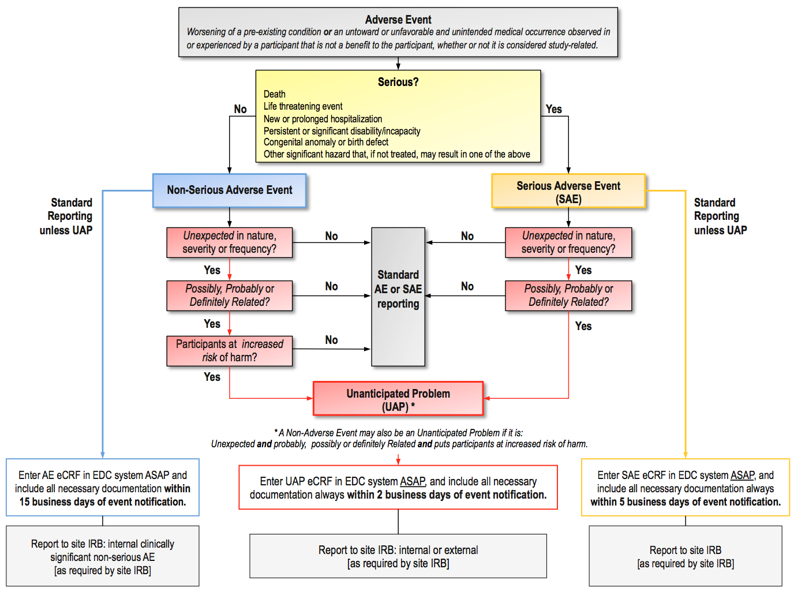
D2d DSMP Figure 2. Algorithm for monitoring of serum calcium.

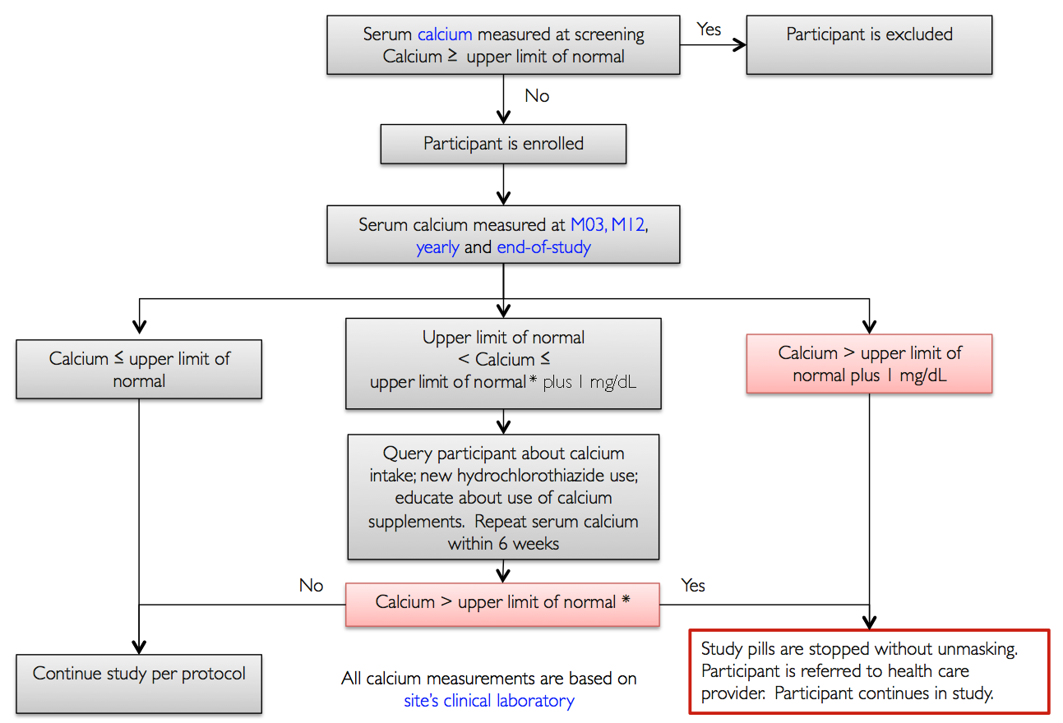

D2d DSMP Figure 3. Algorithm for monitoring of serum creatinine and creatinine clearance (GFR).

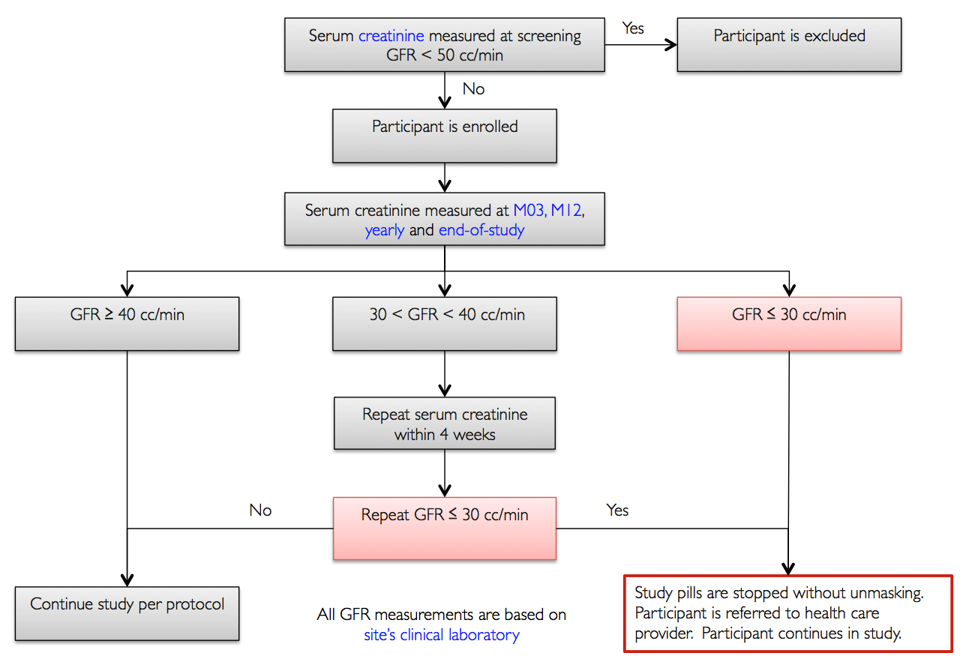

D2d DSMP Figure 4. Algorithm for monitoring of urine calcium-creatinine ratio.

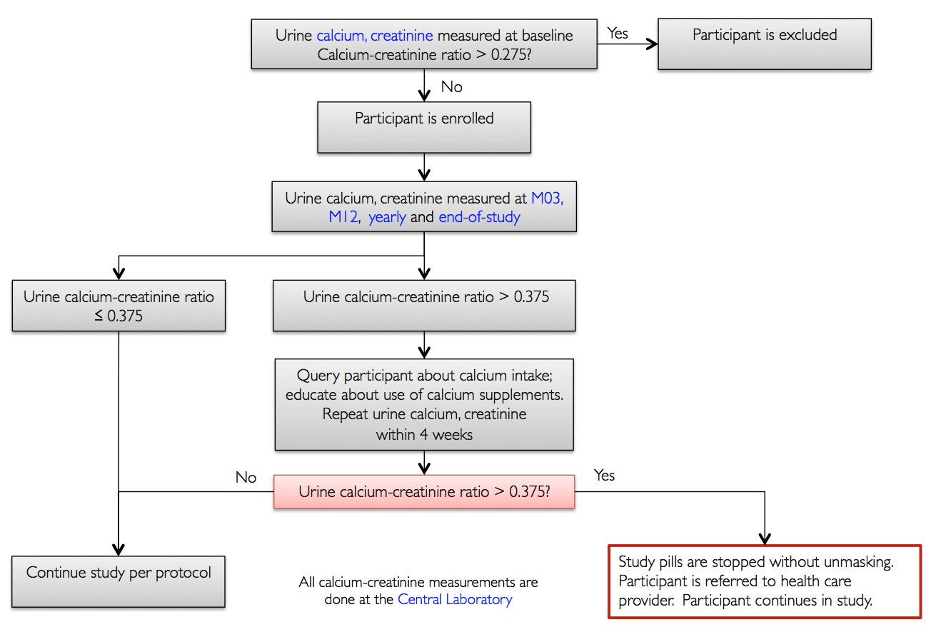

D2d DSMP Figure 5. Algorithm for monitoring of pregnancy.

